6/5 Maths w/c 20th April 2020

3. Ratio & Proportion – Ratio and Fractions

It is important not to get ratio and fractions mixed up. With ratio, you compare the amount of one type (e.g. cats) with the amount of another type (e.g. dogs)

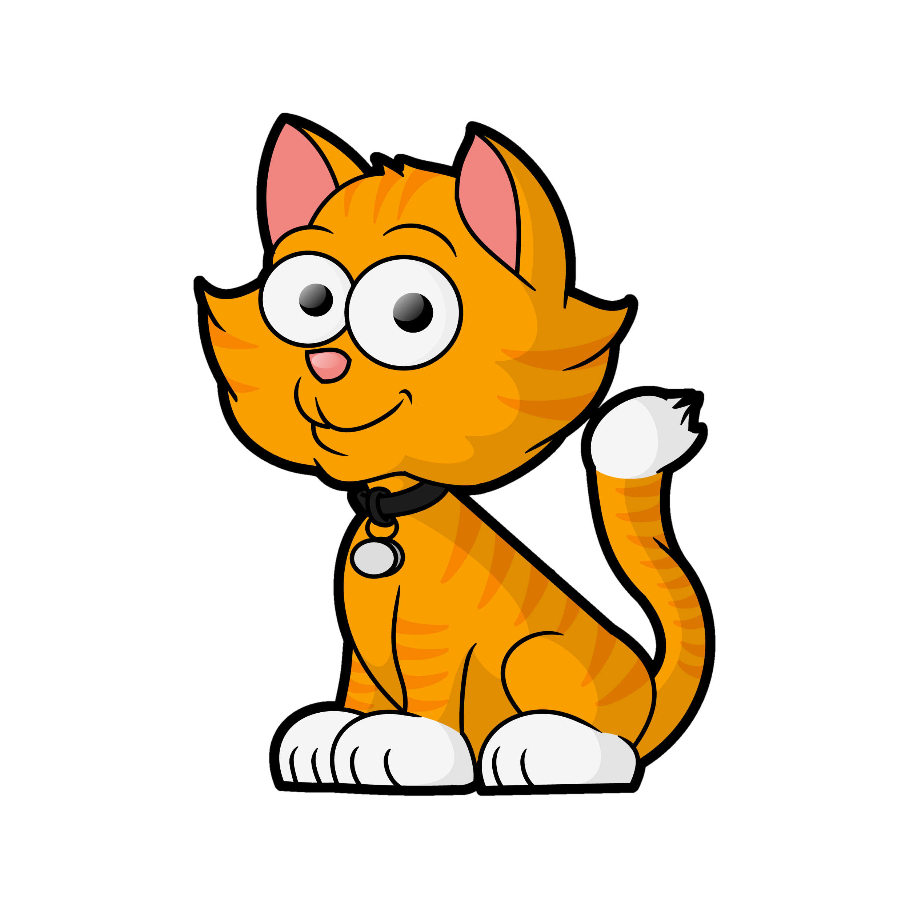

My group of animals is made up of 6 animals in total.
There are 2 cats and 4 dogs.

number of cats | number of dogs
The ratio of cats to dogs is 2:4

In fractions, you compare the amount of one type with the amount of the whole.

In my group of 6 animals, 2 are cats which is $\frac{2}{6}$

The fraction of the group that is cats is $\frac{2}{6}$

In my group of 6 animals, 4 are dogs which is $\frac{4}{6}$.

The fraction of the group that is dogs is $\frac{4}{6}$

Look at these circles.

My group of circles is made up of 3 circles in total. There is 1 red circle and 2 blue circles.

1. What is the ratio of red circles to blue circles?

number of red | number of blue
The ratio of red to blue is __:__

2. What fraction of the group is red?

In my group of _____ circles, ____ are red
The fraction of the group that is red is | number of red
 | number of the whole group
Look at this group of fruit.

3. How many pieces of fruit are there altogether in the group? ___

4. How many bananas are there? ___

5. How many apples are there? ___

6. What is the ratio of bananas to apples? __ : __

7. What is the ratio of apples to bananas? __ : __

8. What fraction of the group is bananas?

9. What fraction of the group is apples?

Look at these squares.

10. What is the ratio of yellow to blue?

11. What fraction is blue?

12. TRUE or FALSE – the fraction that is yellow is $\frac{3}{5}$
Explain why.

