Year 6 R.E, Summer Term
(Week One and Two)

Introduction

Below is all of the work for R.E for 2 weeks worth of lessons. Please follow the work in order, read all of the information, and complete all of the tasks. Click on the hyperlink to open the correct website, or copy and paste it into your internet browser. If you are finding the reading challenging, you can get your computer/tablet or an adult to read it to you.

Lesson 1 – 1hr (20th-24th April)
L.F Humanism
- Watch the video and read the information on Humanism: https://www.bbc.co.uk/bitesize/topics/znk647h/articles/zmqpkmn

- Write down 7 key facts about Humanism from the website. Then, underline or highlight the ones that you think are most important to Humanists. Can you explain why you have chosen those ones?

- Create a ‘Humanism’ poster. Follow the success criteria:
D – Include the title ‘Humanism’ spelt correctly.
D – Include at least 5 key facts about Humanism.
S – Include at least 7 key facts about Humanism.
S – Write a short paragraph explaining what Humanism is.
S+ - Compare Humanism to Christianity. What are the similarities and differences?
S+ - Compare Humanism to your viewpoints. Do you see any similarities between yourself and Humanism?

- Once finished look back at the success criteria. Tick off the ones you have completed. Then try and challenge yourself to add one more!

Lesson 2- 1hr (27^{t} April - 1st May)
L.F How are world views created?
- Watch the video about ‘world views’: https://www.youtube.com/watch?v=VXnSE0uvwzM

- Complete the following tasks:

D – Write down three facts about world views from the video
S – Write a sentence or short paragraph that explains what ‘world view’ means.
S+ - Write a short paragraph explaining why the term ‘world view’ is a key word for the topic of Humanism.

- Everyone has their own world view. Below are examples of things that could shape your world view.
Circle all of the ones that are important to you, or the ones that you agree with or believe in.
There are two empty boxes. Can you add two other things that are important to you? E.g saving the environment, giving to charity..
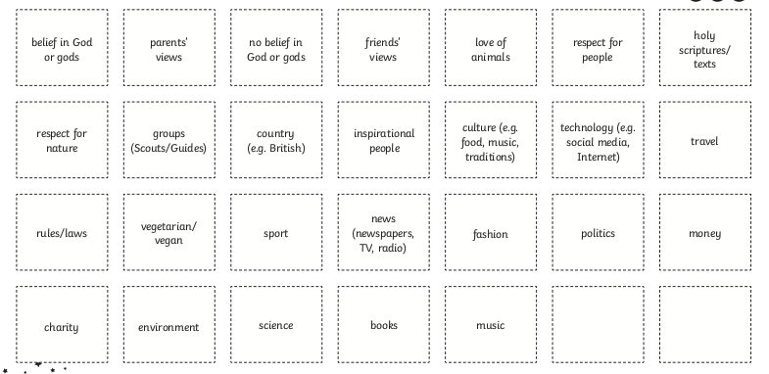

- Can you add the term ‘world view’, with a definition (what the word means), to your Humanism poster from last week?

