7/4 Maths w/c 20th April 2020

2. We are learning what a ‘mixed number’ is and how to turn mixed numbers into fractions.

Let’s think about our cake again.
We said that one of these pieces would be ¼.
Two pieces would be $\frac{2}{4}$
The whole cake would be $\frac{4}{4}$ (notice that the numbers on the top and bottom of the fraction are the same).

What if there were two cakes?
We could have all of the first cake and
two pieces from the second cake. That would
be 1 $\frac{2}{4}$ (one and two quarters)
When we have a whole number and a fraction together like this, it is called a ‘mixed number’.

Find the mixed numbers here and circle them.

4 |  |  |  | 12 |  | 4$\frac{1}{2}$ |  |  | $$\frac{2}{3}$$
 | 1$\frac{1}{3}$ |  | 5 |  | $$\frac{2}{5}$$
 |  | 3 |  |  |  |  | $$\frac{7}{5}$$ |  | 12$\frac{3}{10}$
7$\frac{4}{5}$ |  |  | $$\frac{1}{2}$$ |  | 2$\frac{3}{4}$
10 |  |  |  |  |  |  |  | $$\frac{1}{10}$$

If we have 1 $\frac{2}{4}$ of cake, we can also say that we have $\frac{6}{4}$ – count the pieces for one whole cake and two pieces of the second cake to check that they add up to 6. | 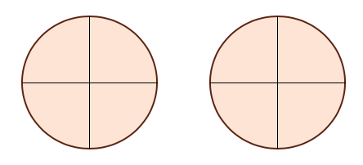

How many parts are in each of these pictures? Write the answer as a fraction.

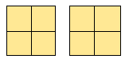 | 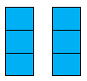

When the top number on a fraction is bigger than the bottom number, it is telling us that the fraction means more than one of something – like more than one cake above.

Here are three bars. Each is split into three equal parts (thirds).

Explain why 2 $\frac{1}{3}$ is the same as $\frac{7}{3}$ using the picture below.

Write down the amount of shaded parts as a fraction and a mixed number. Some have been done already.

 | Mixed Number | Fraction
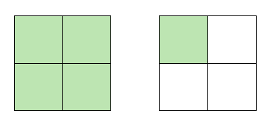 |  | $$\frac{5}{4}$$
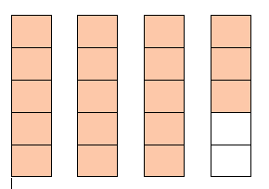 | 3$\frac{3}{5}$
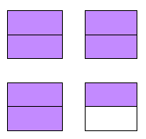

Using a number line for mixed numbers.

Watch this video for a demonstration on how mixed numbers work on a number line. https://www.khanacademy.org/math/cc-third-grade-math/imp-fractions/imp-fractions-on-the-number-line/v/fractions-greater-than-1-on-the-number-line

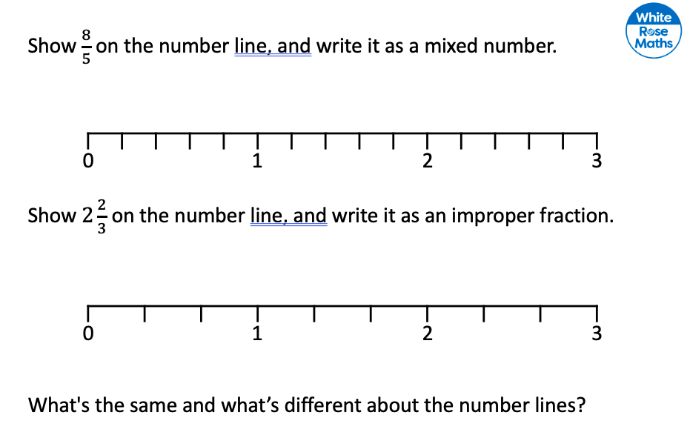

EXTRA CHALLENGE: So, how can we switch between them without pictures or number lines?

Take 2$\frac{1}{4}$ as a mixed number. To turn this into a fraction I do the following steps:
a) look at the bottom of the fraction to see what type of parts we have – in this case it is quarters 2$\frac{1}{4}$
b) look at the first part of the mixed number – 2$\frac{1}{4}$.
c) I know that there are 4 quarters in a whole one. How many would be in 2 whole ones? 4 quarters x 2 whole ones = 8 quarters.
d) Now I add the 8 quarters that make up my ‘2’ to the $\frac{1}{4}$ left in the fraction bit. This gives $\frac{9}{4}$.

One more example:

Turn 1$\frac{1}{3}$ into a fraction.

a) we are working with thirds. 1$\frac{1}{3}$
b) there is one whole one 1$\frac{1}{3}$
c) there are three thirds in one whole one.
d) add the three thirds for the first part of the mixed number to the one third in the fraction part - $\frac{4}{3}$

Try some yourself. If you get stuck, try drawing a picture or number line to help.

Mixed number | Fraction
1$\frac{1}{4}$
2$\frac{3}{5}$
1$\frac{7}{10}$

