7/4 Maths w/c 20th April 2020

2. We are learning what a ‘mixed number’ is and how to turn mixed numbers into fractions. - ANSWERS

4 |  |  |  | 12 |  | 4$\frac{1}{2}$ |  |  | $$\frac{2}{3}$$
 | 1$\frac{1}{3}$ |  | 5 |  | $$\frac{2}{5}$$
 |  | 3 |  |  |  |  | $$\frac{7}{5}$$ |  | 12$\frac{3}{10}$
7$\frac{4}{5}$ |  |  | $$\frac{1}{2}$$ |  | 2$\frac{3}{4}$
10 |  |  |  |  |  |  |  | $$\frac{1}{10}$$

How many parts are in each of these pictures? Write the answer as a fraction.

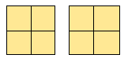 | 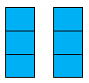
$$\frac{8}{4}$$ | $$\frac{6}{3}$$

When the top number on a fraction is bigger than the bottom number, it is telling us that the fraction means more than one of something – like more than one cake above.

Explain why 2 $\frac{1}{3}$ is the same as $\frac{7}{3}$ using the picture below.

1 | 2 | 3 | 1 whole one
 |  |  | plus
4 | 5 | 6 | 1 whole one
 |  |  | = 2 whole ones +
7 |  |  | $\frac{1}{3}$

Write down the amount of shaded parts as a fraction and a mixed number. Some have been done already.

 | Mixed Number | Fraction
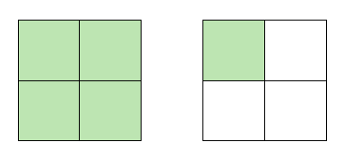 | 1$\frac{1}{4}$ | $$\frac{5}{4}$$
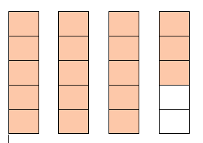 | 3$\frac{3}{5}$ | $$\frac{18}{5}$$
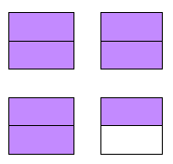 | 3$\frac{1}{2}$ | $$\frac{7}{2}$$

Using a number line for mixed numbers.

Watch this video for a demonstration on how mixed numbers work on a number line. https://www.khanacademy.org/math/cc-third-grade-math/imp-fractions/imp-fractions-on-the-number-line/v/fractions-greater-than-1-on-the-number-line

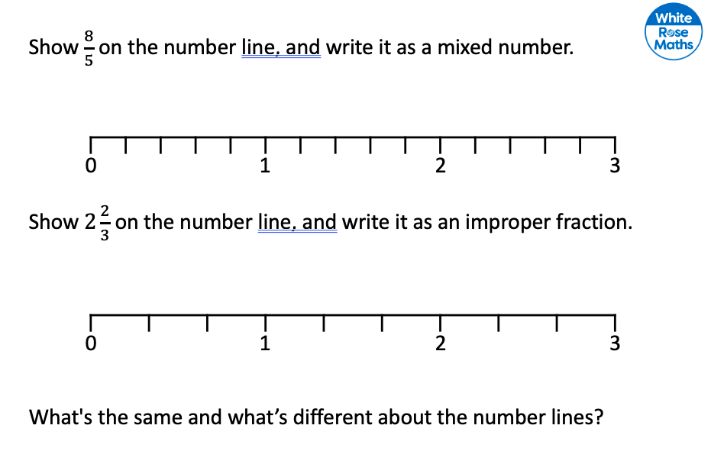

EXTRA CHALLENGE: So, how can we switch between them without pictures or number lines?

Mixed number | Fraction
1$\frac{1}{4}$ | $$\frac{5}{4}$$
2$\frac{3}{5}$ | $$\frac{13}{5}$$
1$\frac{7}{10}$ | $$\frac{17}{10}$$

