Displacement of halides
Setting the scene
The elements of Group 7 are known as the halogens. Observing their reactions can tell you how reactive each element is. Halogens are extremely hazardous and must be handled with care when used. Scientists write risk assessments before using chemicals so people know how to keep safe in an experiment.
Aims
In this activity you will:
- make observations on reactions of halogens
- determine the reactivity of the halogens
- look at hazard symbols to decide what they mean
- suggest safety precautions for using Group 7 elements.
You will be working scientifically to:
- evaluate risk
- interpret observations to identify patterns and draw conclusions.
Task 1
- Your teacher is going to demonstrate how each Group 7 element dissolved in water (called halogen water) reacts with solutions of Group 7 compounds.
- A more reactive halogen will displace a less reactive halogen element from its compounds.
- Fill in the following table with your observations.
Halogen water used | Observations when added to potassium chloride solution | Observations when added to potassium bromide solution | Observations when added to potassium iodide solution
chlorine water
bromine water
iodine water
1 State what is meant by a displacement reaction.

2 State three possible observations during any chemical reaction.

3 Describe the observation in this experiment that demonstrates a chemical reaction has taken place.

4 Use your observations above to write an order of reactivity for the halogens, starting with the most reactive. Explain your answer using your observations.

Extension
1 Write word equations for the displacement reactions that took place.

2 Using the pattern in reactivity for Group 7 elements, predict if chlorine water will react with lithium fluoride. Explain your answer.

Task 2
Look at the picture of Group 7 elements below:
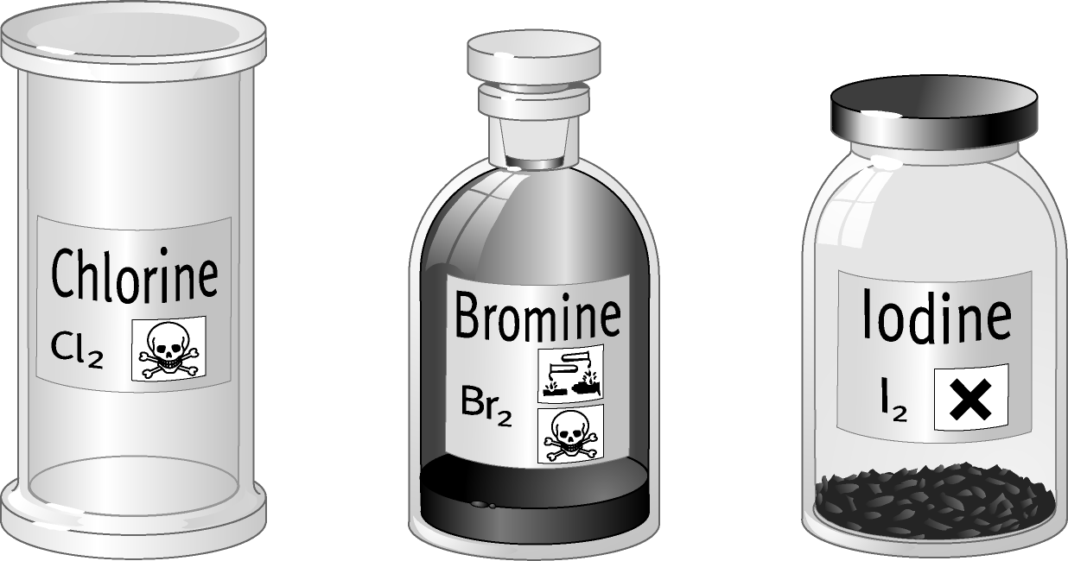

1 Write the hazards shown for each of the Group 7 elements shown. Use the table below.
Group 7 element | Hazard symbol | Description of hazard
chlorine
bromine
iodine
2 List any safety measures needed when using Group 7 elements. Remember that
each of the elements is either a gas or is able to turn easily into a gas at
room temperature. For each safety precaution you give, you should explain why it
is necessary.

Extension
Risk assessments are usually completed in ready-made grids. Use the information above to complete the following risk assessment.

Choose from the answers below to help you complete the last column. You can use the answers more than once and you can have more than one answer for each hazardous substance. Some of the answers provided will not be relevant.
Possible actions that can be taken in the event of injuries/contact with substances:
- shut windows and doors
- get into fresh air
- seek medical attention
- open windows
- wash skin thoroughly with plenty of water
- apply hand cream
- use air freshener
- drink milk
- inform laboratory technician
- inform emergency services
Risk assessment for halogen displacement reactions
Hazardous  substance | Who is at risk from this substance? | Safety measures required when using this substance | Actions needed if  injury/contact  with hazardous substance

