6/5 Maths w/c 27th April 2020

3. Ratio and Proportion Problems

Banana surprise dessert – for 2 people

- 8 strawberries
- 4 digestive biscuits
- 2 pots of yogurt

How could I work out what ingredients I need if I want to make banana surprise for 4 people?

This is like the scale factor problem. My new group of people (4) is two times bigger than the recipe group of people (2). So, I need to multiply all the ingredients by 2 (the scale factor) to get the correct amount of ingredients.

 | Recipe | Scale factor | My group
Strawberries | 8 | 2 | 16
Digestive biscuits | 4 | 2 | 8
Pots of yogurt | 2 | 2 | 4

You can see this in the picture below. The first group is the recipe amount.

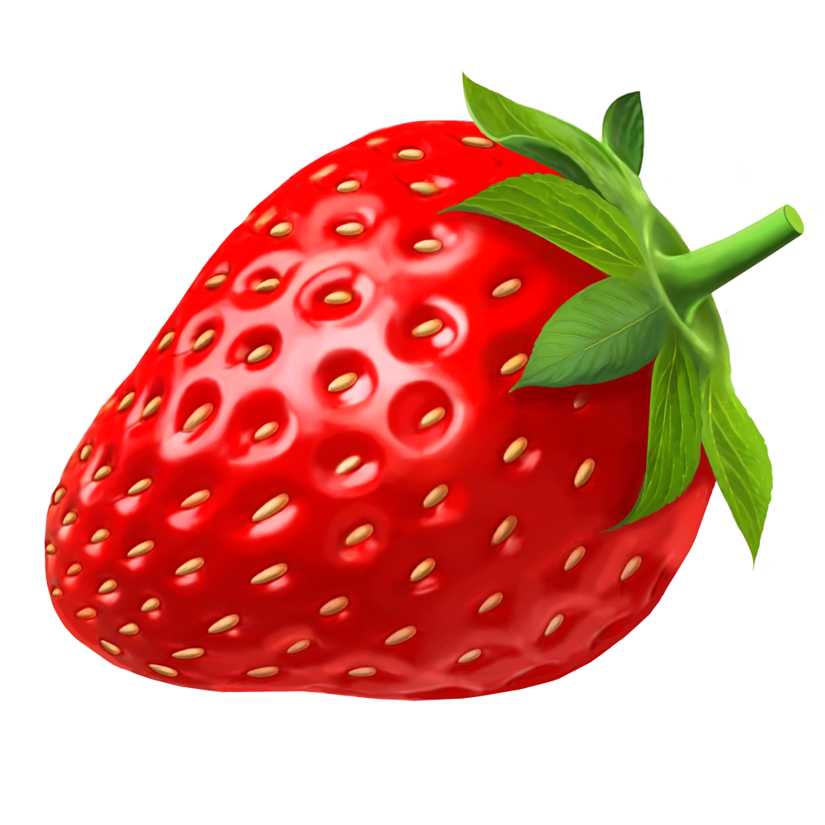

Because I have two times as many people, I need two groups.

Can you use pictures to work out what ingredients I would need for one person?

What about 5 people?

