6/5 Maths w/c 20th April 2020

1. Ratio & Proportion – Using Ratio Language - ANSWERS

Look at the flowers below. What sentences can you say about the numbers of flowers?

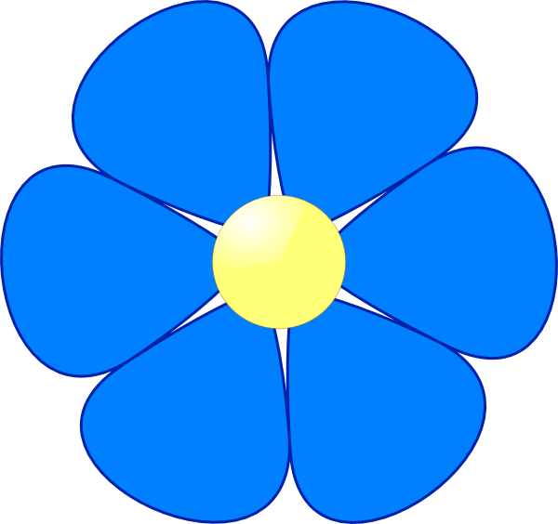

1. For every two blue flowers, there are __6_ pink flowers.

2. For every blue flower, there are __3_ pink flowers.

Look at the cubes below. What ratio sentences can you say about these? If you have cubes, you could use these to help you. If you don’t have cubes, on the next page is a bigger version you could cut out.

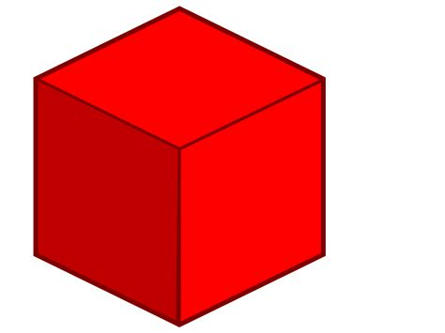

3. For every __16__ red cubes, there are __8__ green cubes.

4. For every 8 red cubes, there are __4__ green cubes.

5. For every green cube, there are __2__ red cubes.

6. EXTRA CHALLENGE: Look at the collection of dots. How many “For every….there are….” sentences could you write about them?

You might find it helpful to start by writing down how many of each colour there are:

Yellow _15___ Blue _5___ Red _3____

For every 15 yellow dots there are 5 blue dots.
For every 15 yellow dots there are 3 red dots.
For every 3 yellow dots there is 1 blue dot.
For every 5 yellow dots there is 1 red dot.
For every 3 red dots, there are 5 blue dots

