6/5 Maths w/c 20th April 2020

2. Ratio & Proportion – The Ratio symbol - ANSWERS

1. The ratio of red circles to blue circles is _4__ : _5__

2. The ratio of blue circles to red circles is _5__ : _4__

Look at these fruits.
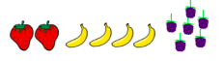

3. What is the ratio of bananas to strawberries? 4:2 or 2:1

4. What is the ratio of blackberries to strawberries? 6:2 or 3:1

5. The ratio of red to green marbles is 3:7. Draw a picture to show this.

