6/5 Maths w/c 20th April 2020

3. Ratio & Proportion – Ratio and Fractions - ANSWERS

Look at these circles.

My group of circles is made up of 3 circles in total. There is 1 red circle and 2 blue circles.

1. What is the ratio of red circles to blue circles?

number of red | number of blue
The ratio of red to blue is _1_:_2_

2. What fraction of the group is red?

In my group of __3___ circles, __1__ are red
The fraction of the group that is red is $\frac{1}{3}$ | number of red
 | number of the whole group
Look at this group of fruit.

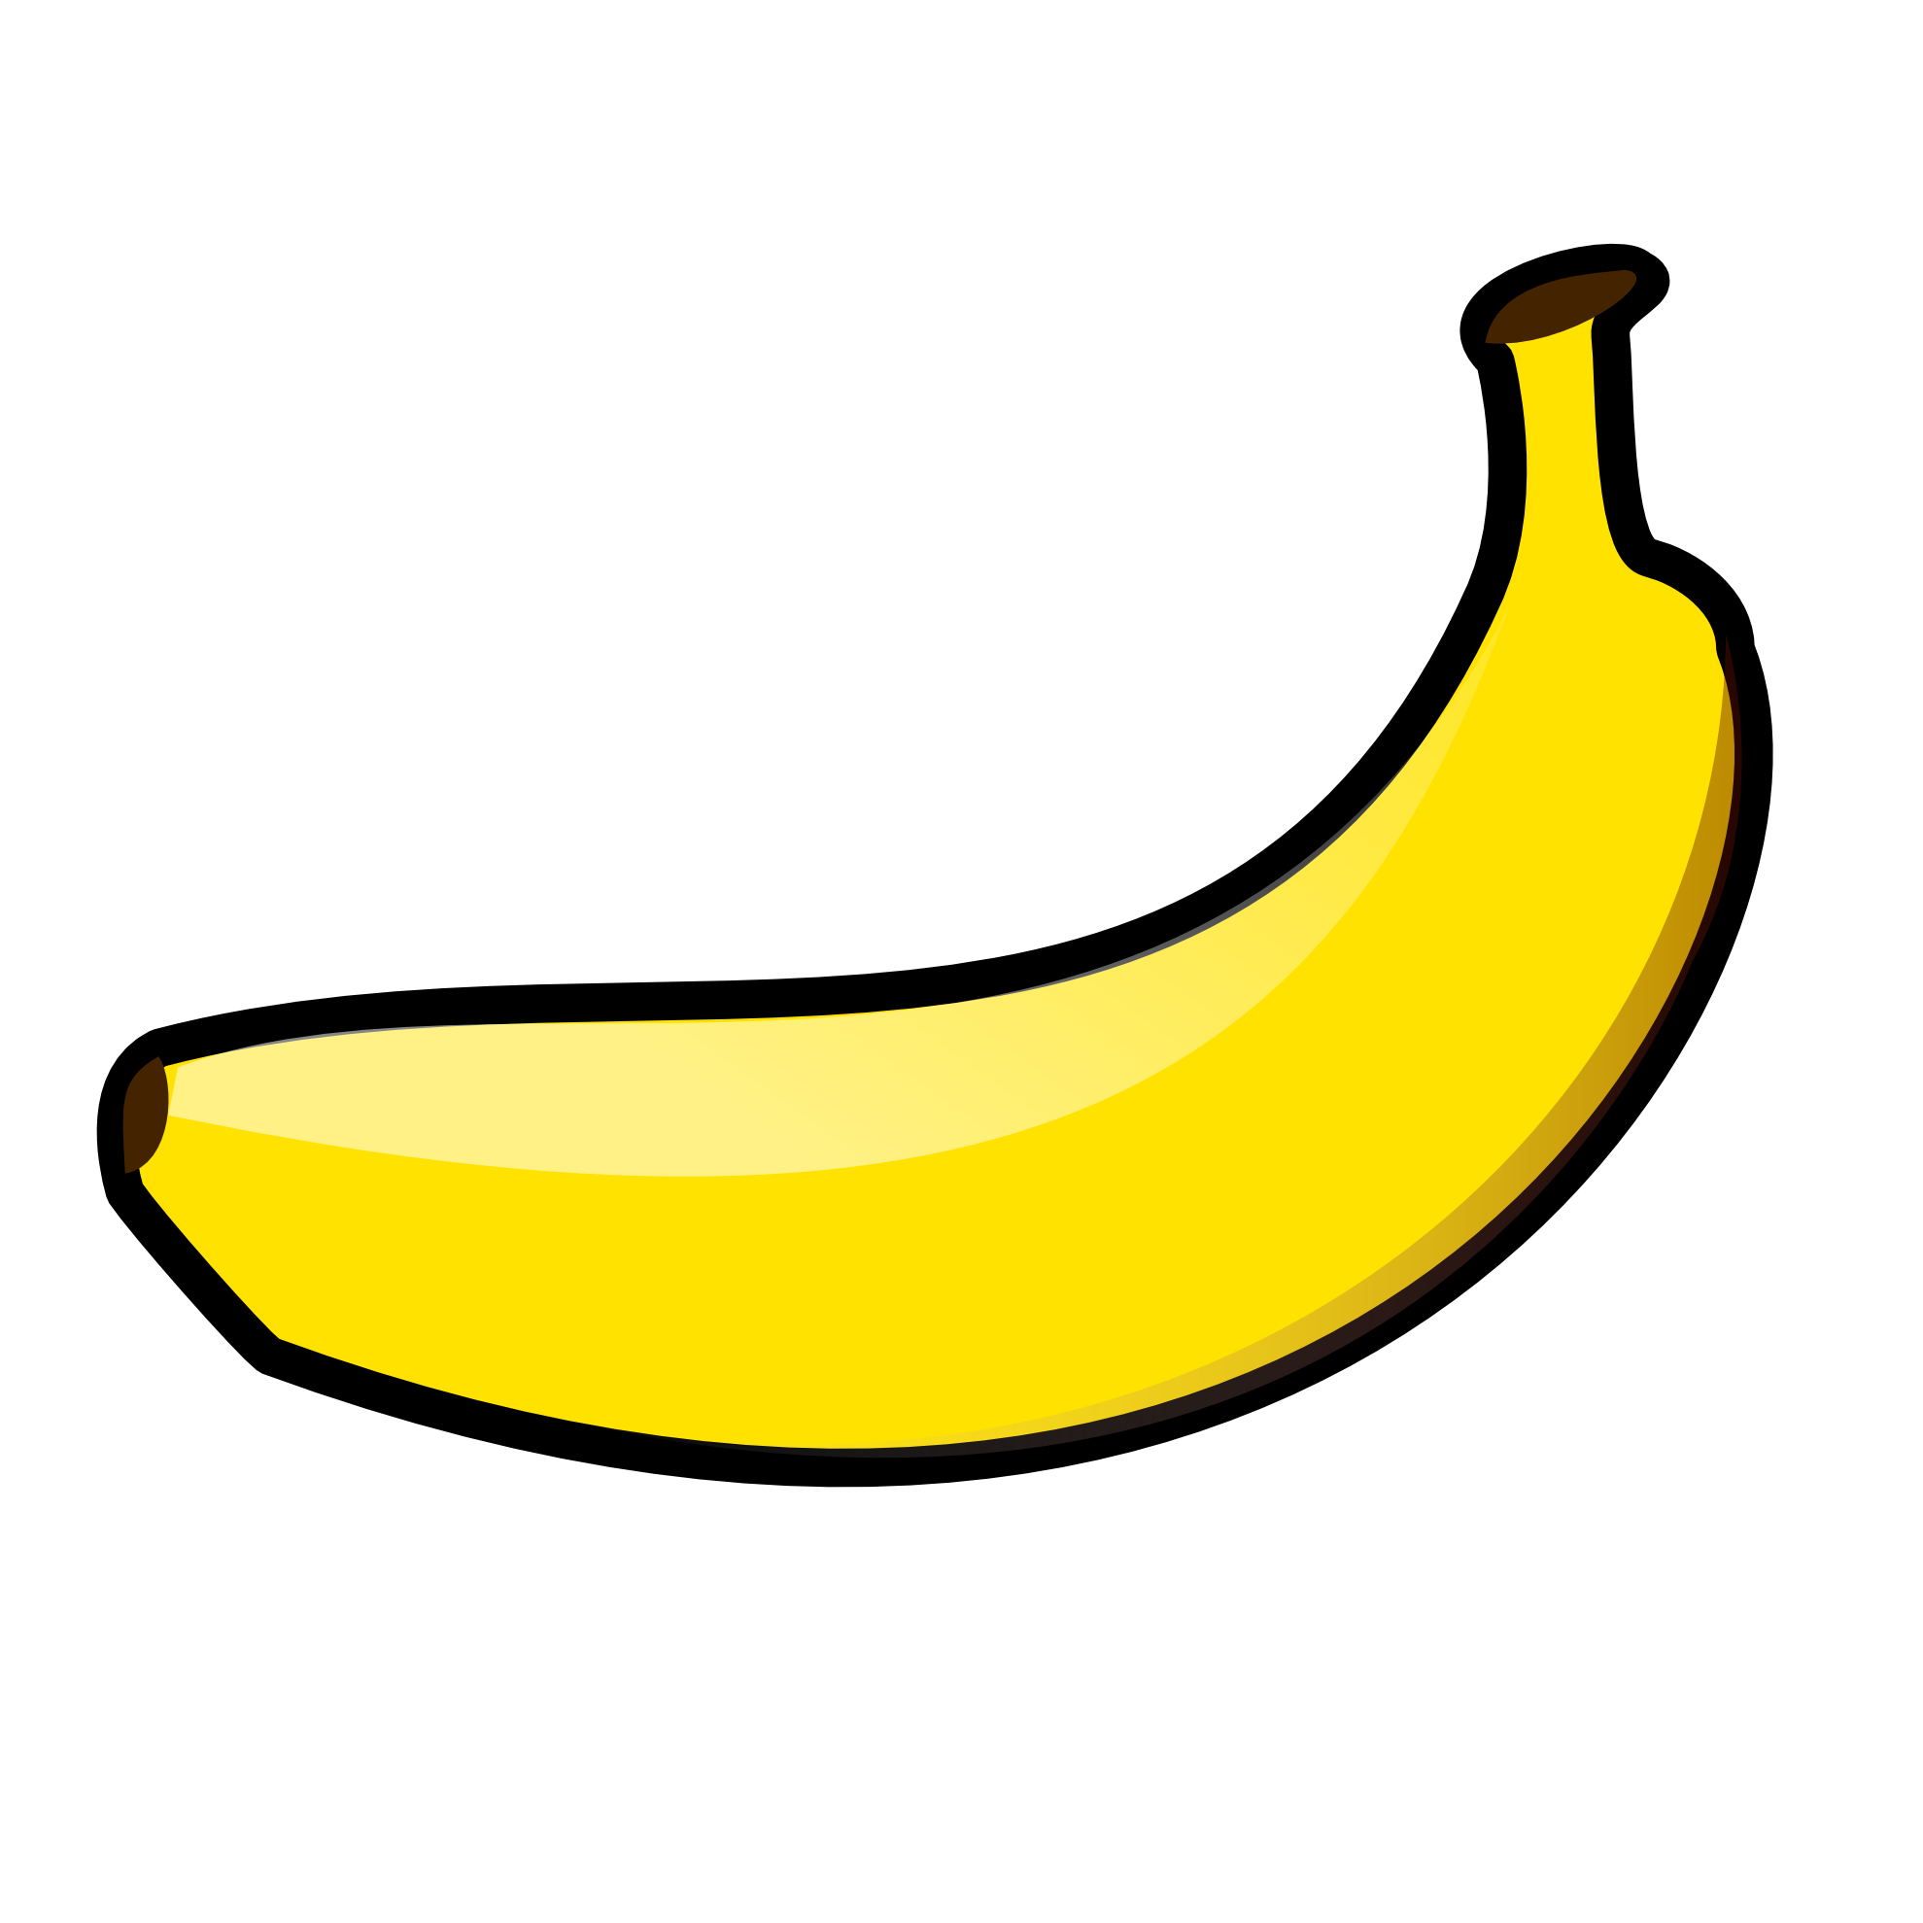
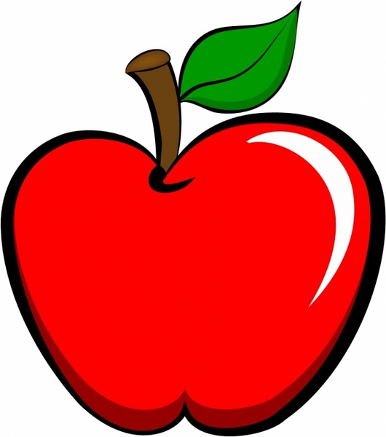

3. How many pieces of fruit are there altogether in the group? __10_

4. How many bananas are there? __6_

5. How many apples are there? _4__

6. What is the ratio of bananas to apples? 6:4 or 3:2

7. What is the ratio of apples to bananas? 4:6 or 2:3

8. What fraction of the group is bananas? $\frac{6}{10}$ or $\frac{3}{5}$

9. What fraction of the group is apples? $\frac{4}{10}$ or $\frac{2}{5}$

Look at these squares.

10. What is the ratio of yellow to blue? 3:5

11. What fraction is blue? $\frac{5}{8}$

12. TRUE or FALSE – the fraction that is yellow is $\frac{3}{5}$
Explain why.

False – there are 8 equal parts to the picture. Therefore, any fraction should be $\frac{?}{8}$

