7/4 Maths w/c 27th April 2020

3. We are learning to understand how different fractions can be equal to each other. - ANSWERS

Which fractions are the same as ½? There are two – write them here.

$\frac{2}{4}$ , $\frac{3}{6}$

Can you explain why we can’t have a thirds fraction or a fifths fraction that is equal to ½ ?
Because none of the thirds or fifths boxes line up with the ½ line.

Here is the number line again with different shading. What fractions are equal to each other?

$$\frac{1}{1}$$
$$\frac{1}{2}$$ |  |  |  |  |  | $$\frac{1}{2}$$
$$\frac{1}{3}$$ |  |  |  | $$\frac{1}{3}$$ |  |  |  | $$\frac{1}{3}$$
$$\frac{1}{4}$$ |  |  | $$\frac{1}{4}$$ |  |  | $$\frac{1}{4}$$ |  |  | $$\frac{1}{4}$$
$$\frac{1}{5}$$ |  | $$\frac{1}{5}$$ |  |  | $$\frac{1}{5}$$ |  | $$\frac{1}{5}$$ |  |  | $$\frac{1}{5}$$
$$\frac{1}{6}$$ | $$\frac{1}{6}$$ |  |  | $$\frac{1}{6}$$ |  | $$\frac{1}{6}$$ |  | $$\frac{1}{6}$$ |  |  | $$\frac{1}{6}$$
Use the number lines to try and complete this table.

$$\frac{1}{2}$$ | is equal to | $$\frac{2}{4}$$ | and | $$\frac{3}{6}$$
$$\frac{1}{3}$$ | is equal to | $$\frac{2}{6}$$
$$\frac{2}{3}$$ | is equal to | $$\frac{4}{6}$$

Using the fraction wall sheet and a ruler, try to find other fractions that are equal to the ones below. There might be more than one answer.

$$\frac{1}{2}$$ | $\frac{2}{4}$ , $\frac{3}{6}$ , $\frac{4}{8}$ , $\frac{5}{10}$ , $\frac{6}{12}$
$$\frac{1}{3}$$ | $\frac{2}{6}$ , $\frac{3}{9}$ , $\frac{4}{12}$
$$\frac{1}{4}$$ | $\frac{2}{8}$ , $\frac{3}{12}$
$$\frac{1}{5}$$ | $$\frac{2}{10}$$
$$\frac{1}{6}$$ | $$\frac{2}{12}$$
$$\frac{4}{6}$$ | $\frac{2}{3}$ , $\frac{8}{12}$
$$\frac{3}{12}$$ | $$\frac{1}{4}$$

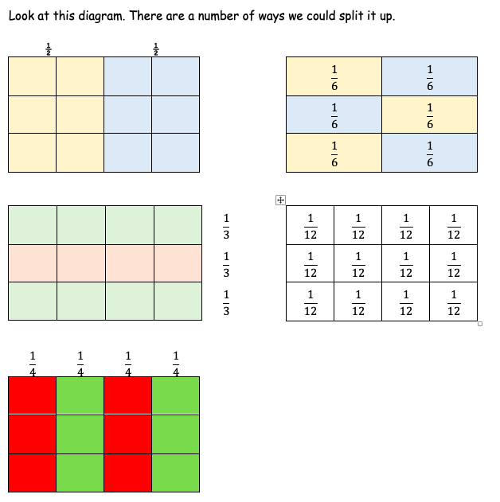
Here is the box again with part of it shaded. How many different fractions can we use to describe the shaded part? | What about in this one? How many fractions can you use to describe the shaded part?
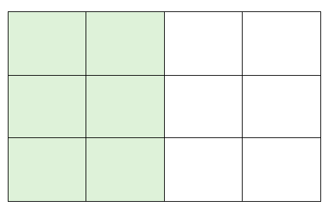 | 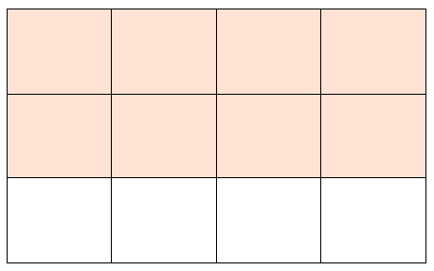
Answers: $\frac{1}{2}$ , $\frac{2}{4}$ , $\frac{3}{6}$ , $\frac{6}{12}$ | Answers: $\frac{2}{3}$ , $\frac{4}{6}$ , $\frac{8}{12}$

