**Angles on a straight line**

**Find the missing angle in each of these diagrams**

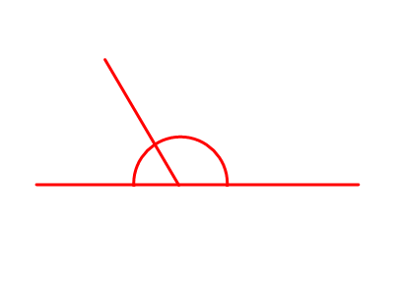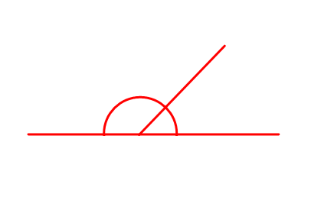******RED** – Start with me

1500

400

1300

300

1400

500

1700

500

100

1300

300

1500



600

700

1400

1600

600

1100

1200

1200

400

200

Found these easy so far? Why not move onto **orange**?

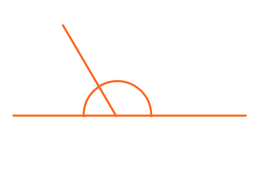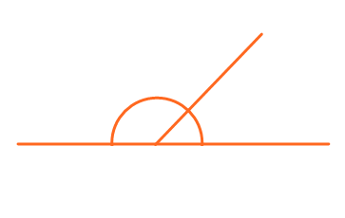**Orange** – Move onto me

1650

1450

1250

150

350

550



1550

250

250

1550

550

1250





450

150

450

1350

1350

1750

1050

50

750

1650