The Alps
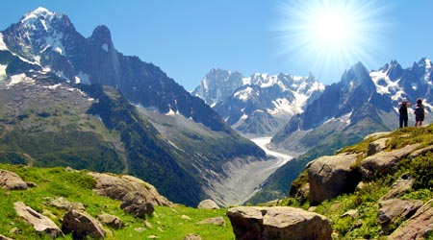
Print

The Alps are the biggest mountain range in Europe. They stretch from Austria and Slovenia in the east all the way through Italy, Switzerland and Germany to France in the west.

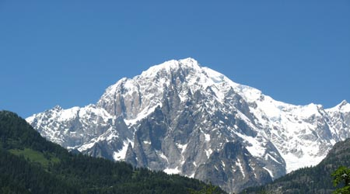
The highest peak in the Alps is Mont Blanc at 4810 metres (15,782 feet). Mont Blanc (French) or Monte Blanco (Italian) means White Mountain.

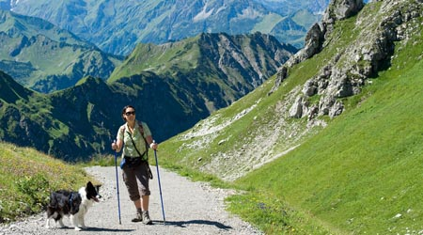
The Alps are probably one of the most popular tourist destinations in Europe. People visit the Alps all year round for many different reasons.
In summer people come here to sightsee, as the picturesque mountains make a wonderful backdrop. In summer activities such as hiking, mountain biking, mountaineering and paragliding are popular.

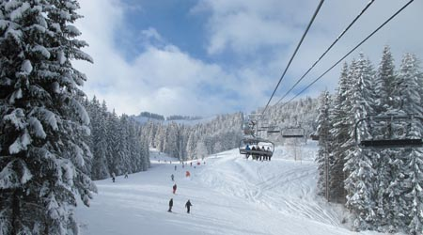
In most regions of the Alps from December to April, winter sports like skiing, snowboarding and tobogganing are extremely popular. Sounds fun!

Don’t forget, this will mean lots of jobs for Italian people such as working as a tour guide, instructor, in hotels and restaurants etc.

The Apennines

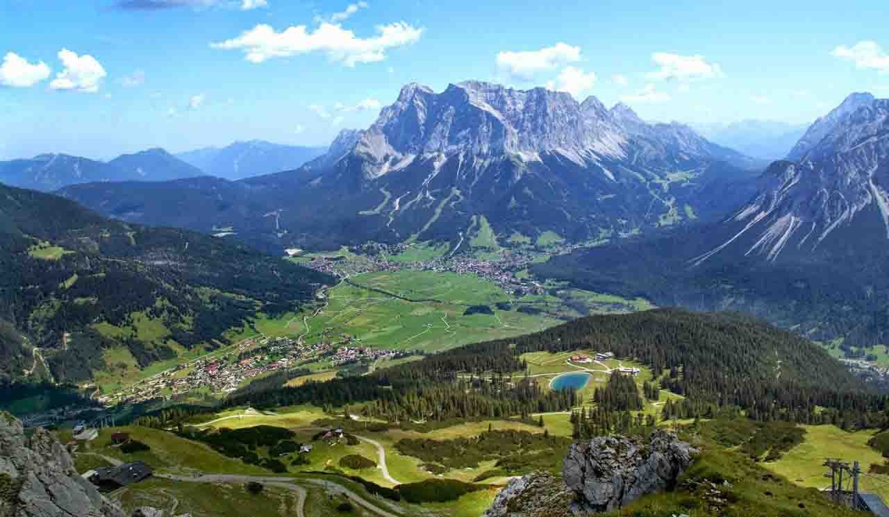
The Apennines stretch 839 miles (1,350 kilometres) north to south covering the entire length of Italy, right through the middle! They also continue into Sicily, Italy’s biggest island.

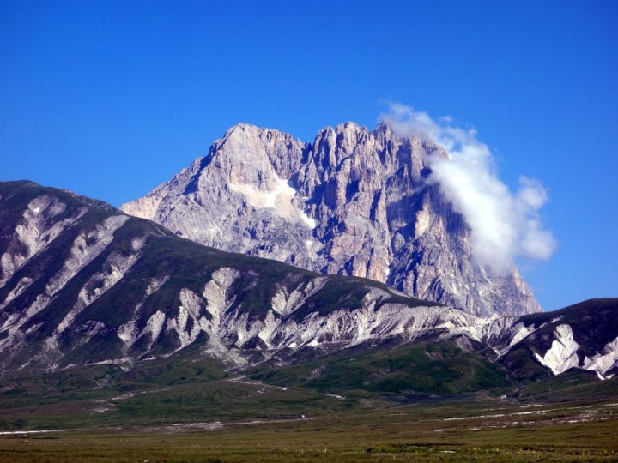

Corno Grande is the tallest mountain in the Apennines. Its peak is 9,554 feet (2,912 meters) above sea level.
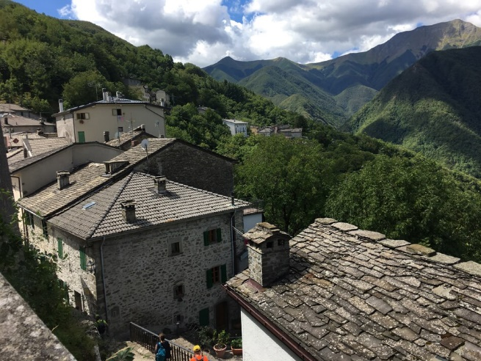

People of Italy have always lived in the Apennine mountain range, in fact, there are villages as high as 5000 metres above sea level!
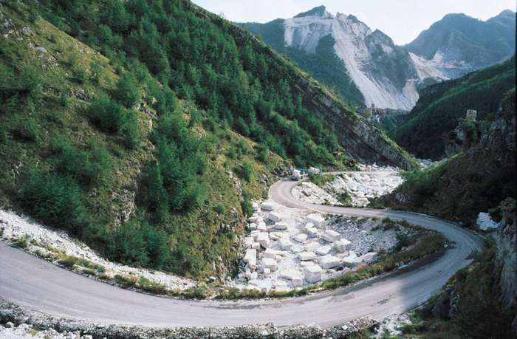

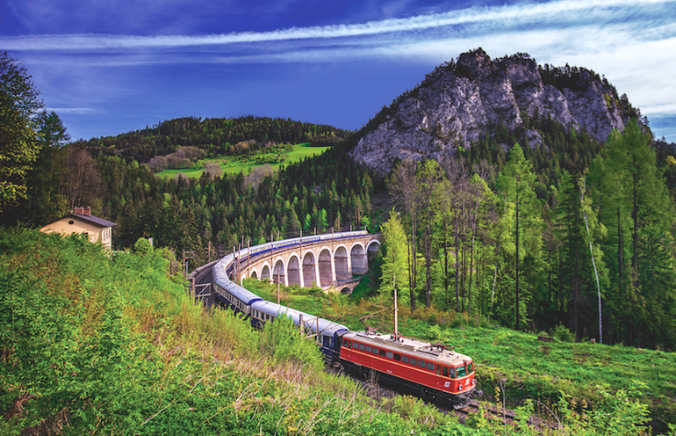
The Apennines also provide many jobs for the people of Italy, including mining and quarries. For example, the picture shows a marble quarry in the mountain range.

Because so many people live and work The Apennines, there needs to be transport around the mountains. Therefore, there are lots of railways and roads around this range.

The Dolomites
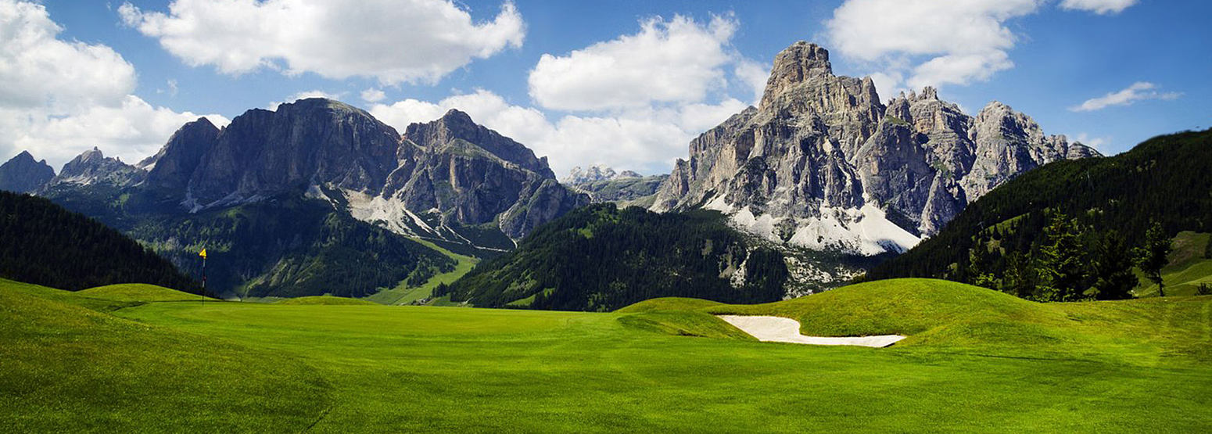

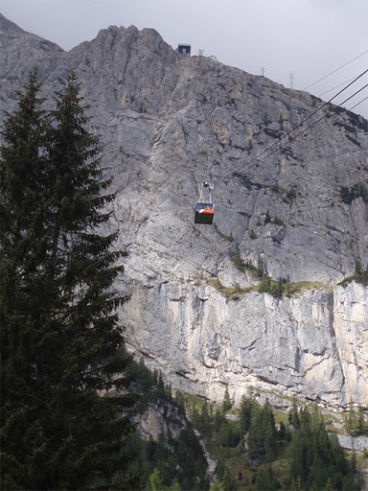
The dolomites are a separate section of The Alps found in the north east of Italy.
The highest peak is the Marmolada which is 10,964 feet, or 3,342 metres above sea level.
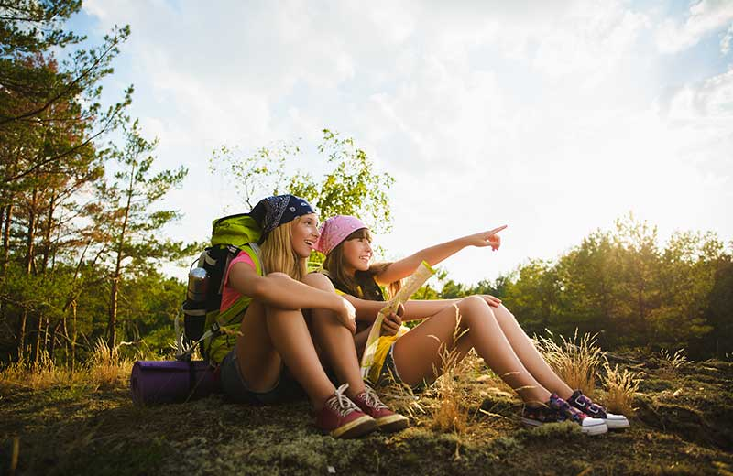
The dolomites are used for many tourist attractions including:
Hiking: There are lots of hiking trails in these mountains to lead tourist through the magnificent forests and to the peak of the famous mountains.

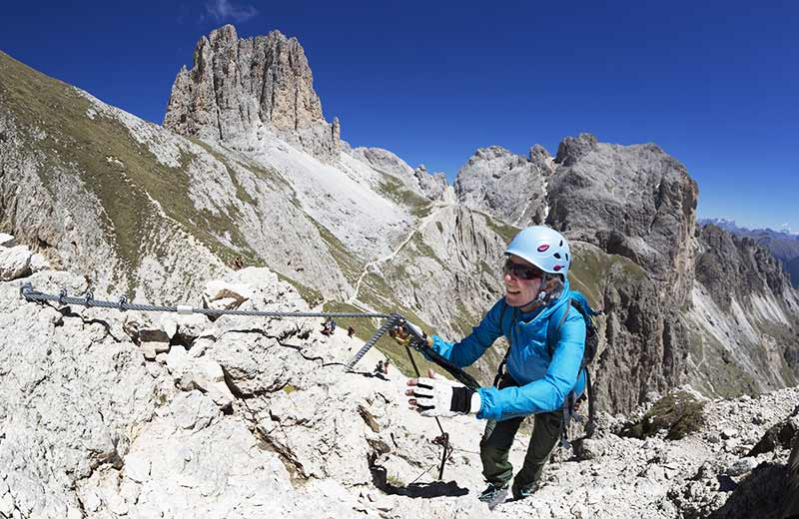
Climbing is a popular activity in these mountains. But, this is mainly done in the spring and summer months when it is safer.
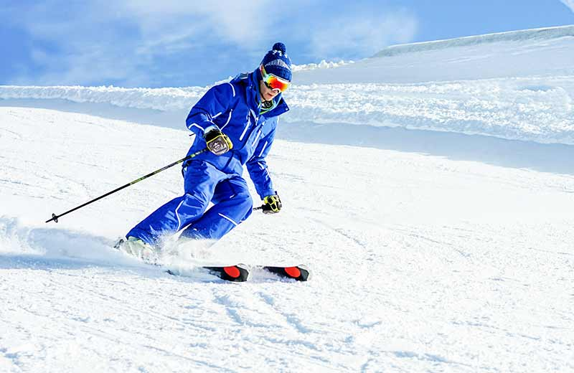
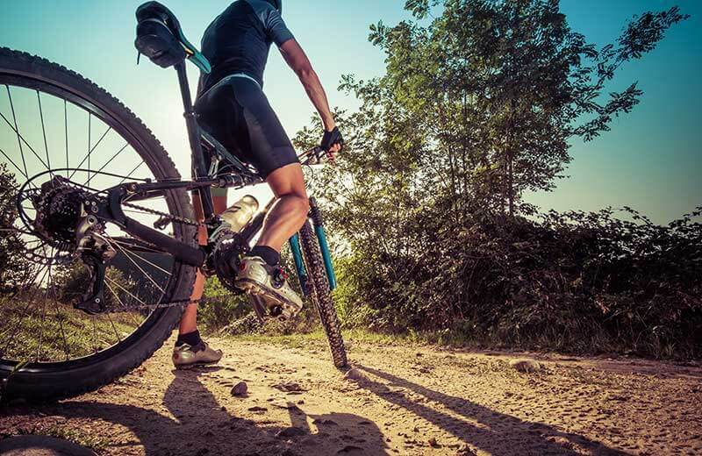
Cycling and mountain biking is a popular sport in the mountain range. There are lots of bike tours and even a major cycling competition that takes place every year.

In the winter months, these mountains are very popular with tourists seeking winter sports including skiing and snowboarding. This means there are lots of ski resorts in this range.
Don’t forget, this will mean lots of jobs for Italian people such as working as a tour guide, instructor, in hotels and restaurants etc.

