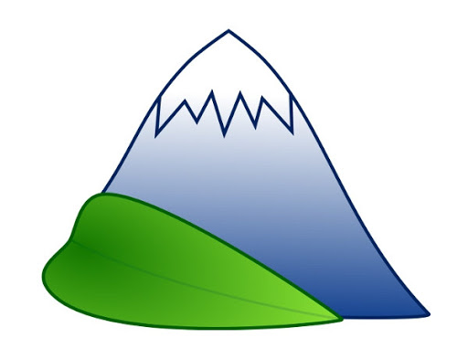
1)
Analyse how Italy’s lakes have been formed
2)
3)
4)
5)
1)  Analyse how Italy’s lakes have been formed | Key words: climate, cold, snowy
2) | Key words: ice, glacier
3) | Key words: glacier, heavy, down
4) | Key words: climate, warm, ice, melt,
5) | Key words: glacier, melts, lake

