Type of erosion | Description (developing) | Diagram (secure) | How is the coast affected? (secure+)
Hydraulic Action | This happens when big, powerful, destructive waves crash against the cliff face. Over time this causes big cracks to appear in the cliff. | 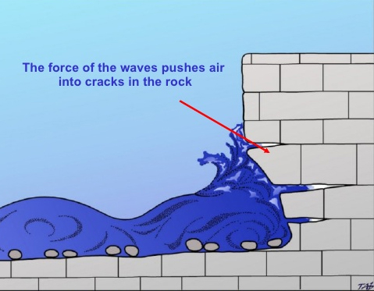  Cracks | Not only will big cracks be created in the cliff face, but these cracks will grow and grow. As the get bigger the air inside of them will get compressed by the water crashing into them and this will cause the air to burst out. This means the cracks will get even bigger!
Attrition | This happens when the rocks which have been eroded from the cliff are taken back into the sea. Whilst in the water they band and crash into each other causing further erosion. This means the rocks get smaller and smaller. | 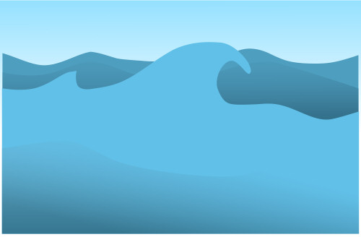  Pebbles crash into each other in the waves | This type of erosion does not directly affect the cliff, it effects the rocks which are eroded from the cliff.
Abrasion | This happens when the rocks that are in the water (which have already been eroded from the cliff) are thrown back against the cliff. The rocks wear away and break off more bits of the cliff. | 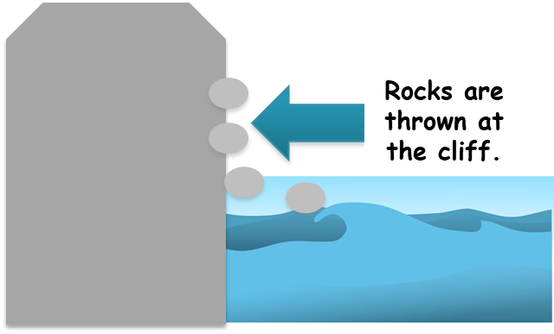 | Abrasion is very destructive as the more it happens, the more powerful the erosion of the cliff will be. This is because the more attrition happens, the more rocks in the water, the more rocks in the water, the more the cliff will be eroded when they are thrown back at it.
Solution | This happens when salt and chemicals inside the waves cause the rocks to dissolve. This can happen to the rocks inside the water but will also happen to the cliff as the water will leave the salt and chemicals on the cliff when the waves hit it. This will cause the cliff to slowly dissolve (erode) | 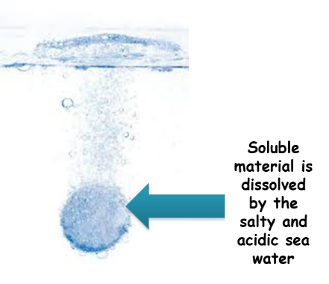 | This type of erosion has a bigger impact when the cliff is made from a more soluble rock which is easier to dissolve, such as limestone or chalk (like The White Cliffs of Dover).

