Models for Electric Circuits – S+

TASK: Create your own model for the flow of electricity in a circuit. Your model needs to include something that represents a cell, wires and a bulb.
Things you need to think about:
- How the electrical energy gets from the cell to the bulb
- Electrical energy is transferred by a carrier, remember this needs to return to the cell to get more energy
- The circuit needs to be complete.
- Be Creative – There are no wrong answers!

You cannot use the examples shown by the teacher, or those on the S sheets.

Advantages of this model | Disadvantages of this model
Models for Electric Circuits – S

TASK: Create a model for the flow of electricity in a circuit. Your model will be based on an ASDA food delivery truck delivering Mars bars to a house. You need to label the model showing what the cell, the wire and the bulb are.

Things you need to know:
- The delivery truck picks up the Mars bars from the superstore
- It drives along roads to get to the house
- It delivers the Mars bars to the house, giving it energy.
- The truck drives back to the superstore to get more Mars bars

Extension: List two advantages and one disadvantage of your model below.
Advantages of this model | Disadvantages of this model
1.  2. | 1.
Models for Electric Circuits – D

TASK: Create a story board for the flow of electrical energy in the example where we walked around in a circle, picking paper up from the ‘cell’ and putting it down in the ‘bulb’. You need to draw a diagram for each stage of the model. You will need to label the cell, the wire and the bulb in each diagram. The first stage of the model has been drawn below for you.

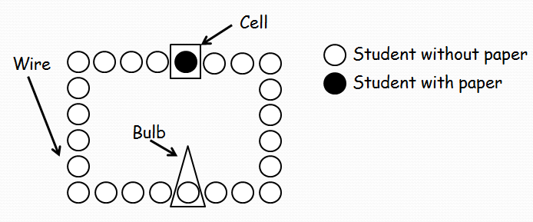  The students are the electrons. When the switch is off, none of the students carry paper. The paper is the electrical energy | When the switch is on, the students being walking around the circuit. As they pass the cell they pick up paper. The paper is the electrical energy.
As the students pass the bulb they drop the paper into the bulb tray. As the paper is electrical energy this causes the bulb to light. | The students who have dropped their paper in the bulb tray need to carry on walking around the circuit until they get back to the bulb where they can pick up more energy.

Extension: Why is this model good for showing how electricity moves around a circuit?

Models for Electric Circuits – WB

TASK: Fill in the missing words for this model of an electric circuit. This model is the central heating model you saw in the lesson.

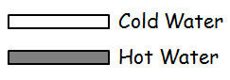  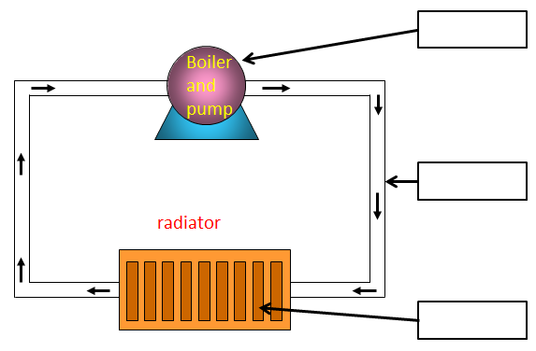  Label the Cell, Wires, Heater | 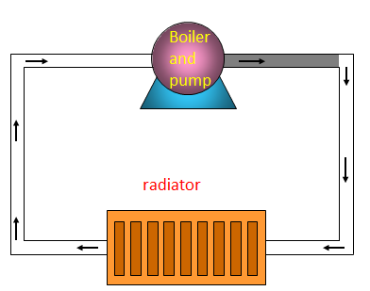  When the circuit is on, the boiler and pump move hot water around the circuit. The hot water represents the ______________ in a circuit.
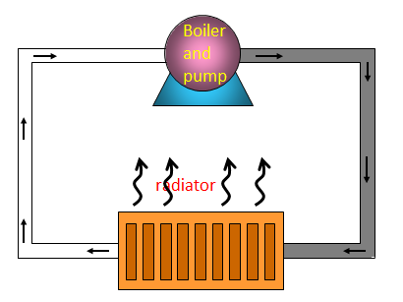  As the hot water enters the radiator, it gives off heat. | The water that leaves the radiator has no heat left in it, so must return to the ____________ to collect more.

Disadvantages of this Model? Think about how quickly the hot water takes to get to the radiator compared with how long it takes for a light to turn on when you flip the switch?

Advantages of this Model? Think about the basic requirements of a circuit? Does this meet those?

