6/5 Maths w/c 1st June 2020

3. We are learning how to draw a line graph – part 2.

Now you are going to try and draw a graph of your own. You will need:
- Squared paper – there is some to download and print if you need it.
- A ruler
- A pencil

Your graph is going to show how many cakes were in Ms Haden’s cupboard last week.

Your X-axis needs room for 7 days. You can decide how spaced out you want them to be BUT the spaces between each day needs to be the same.

You can draw them with only one space between each like this:
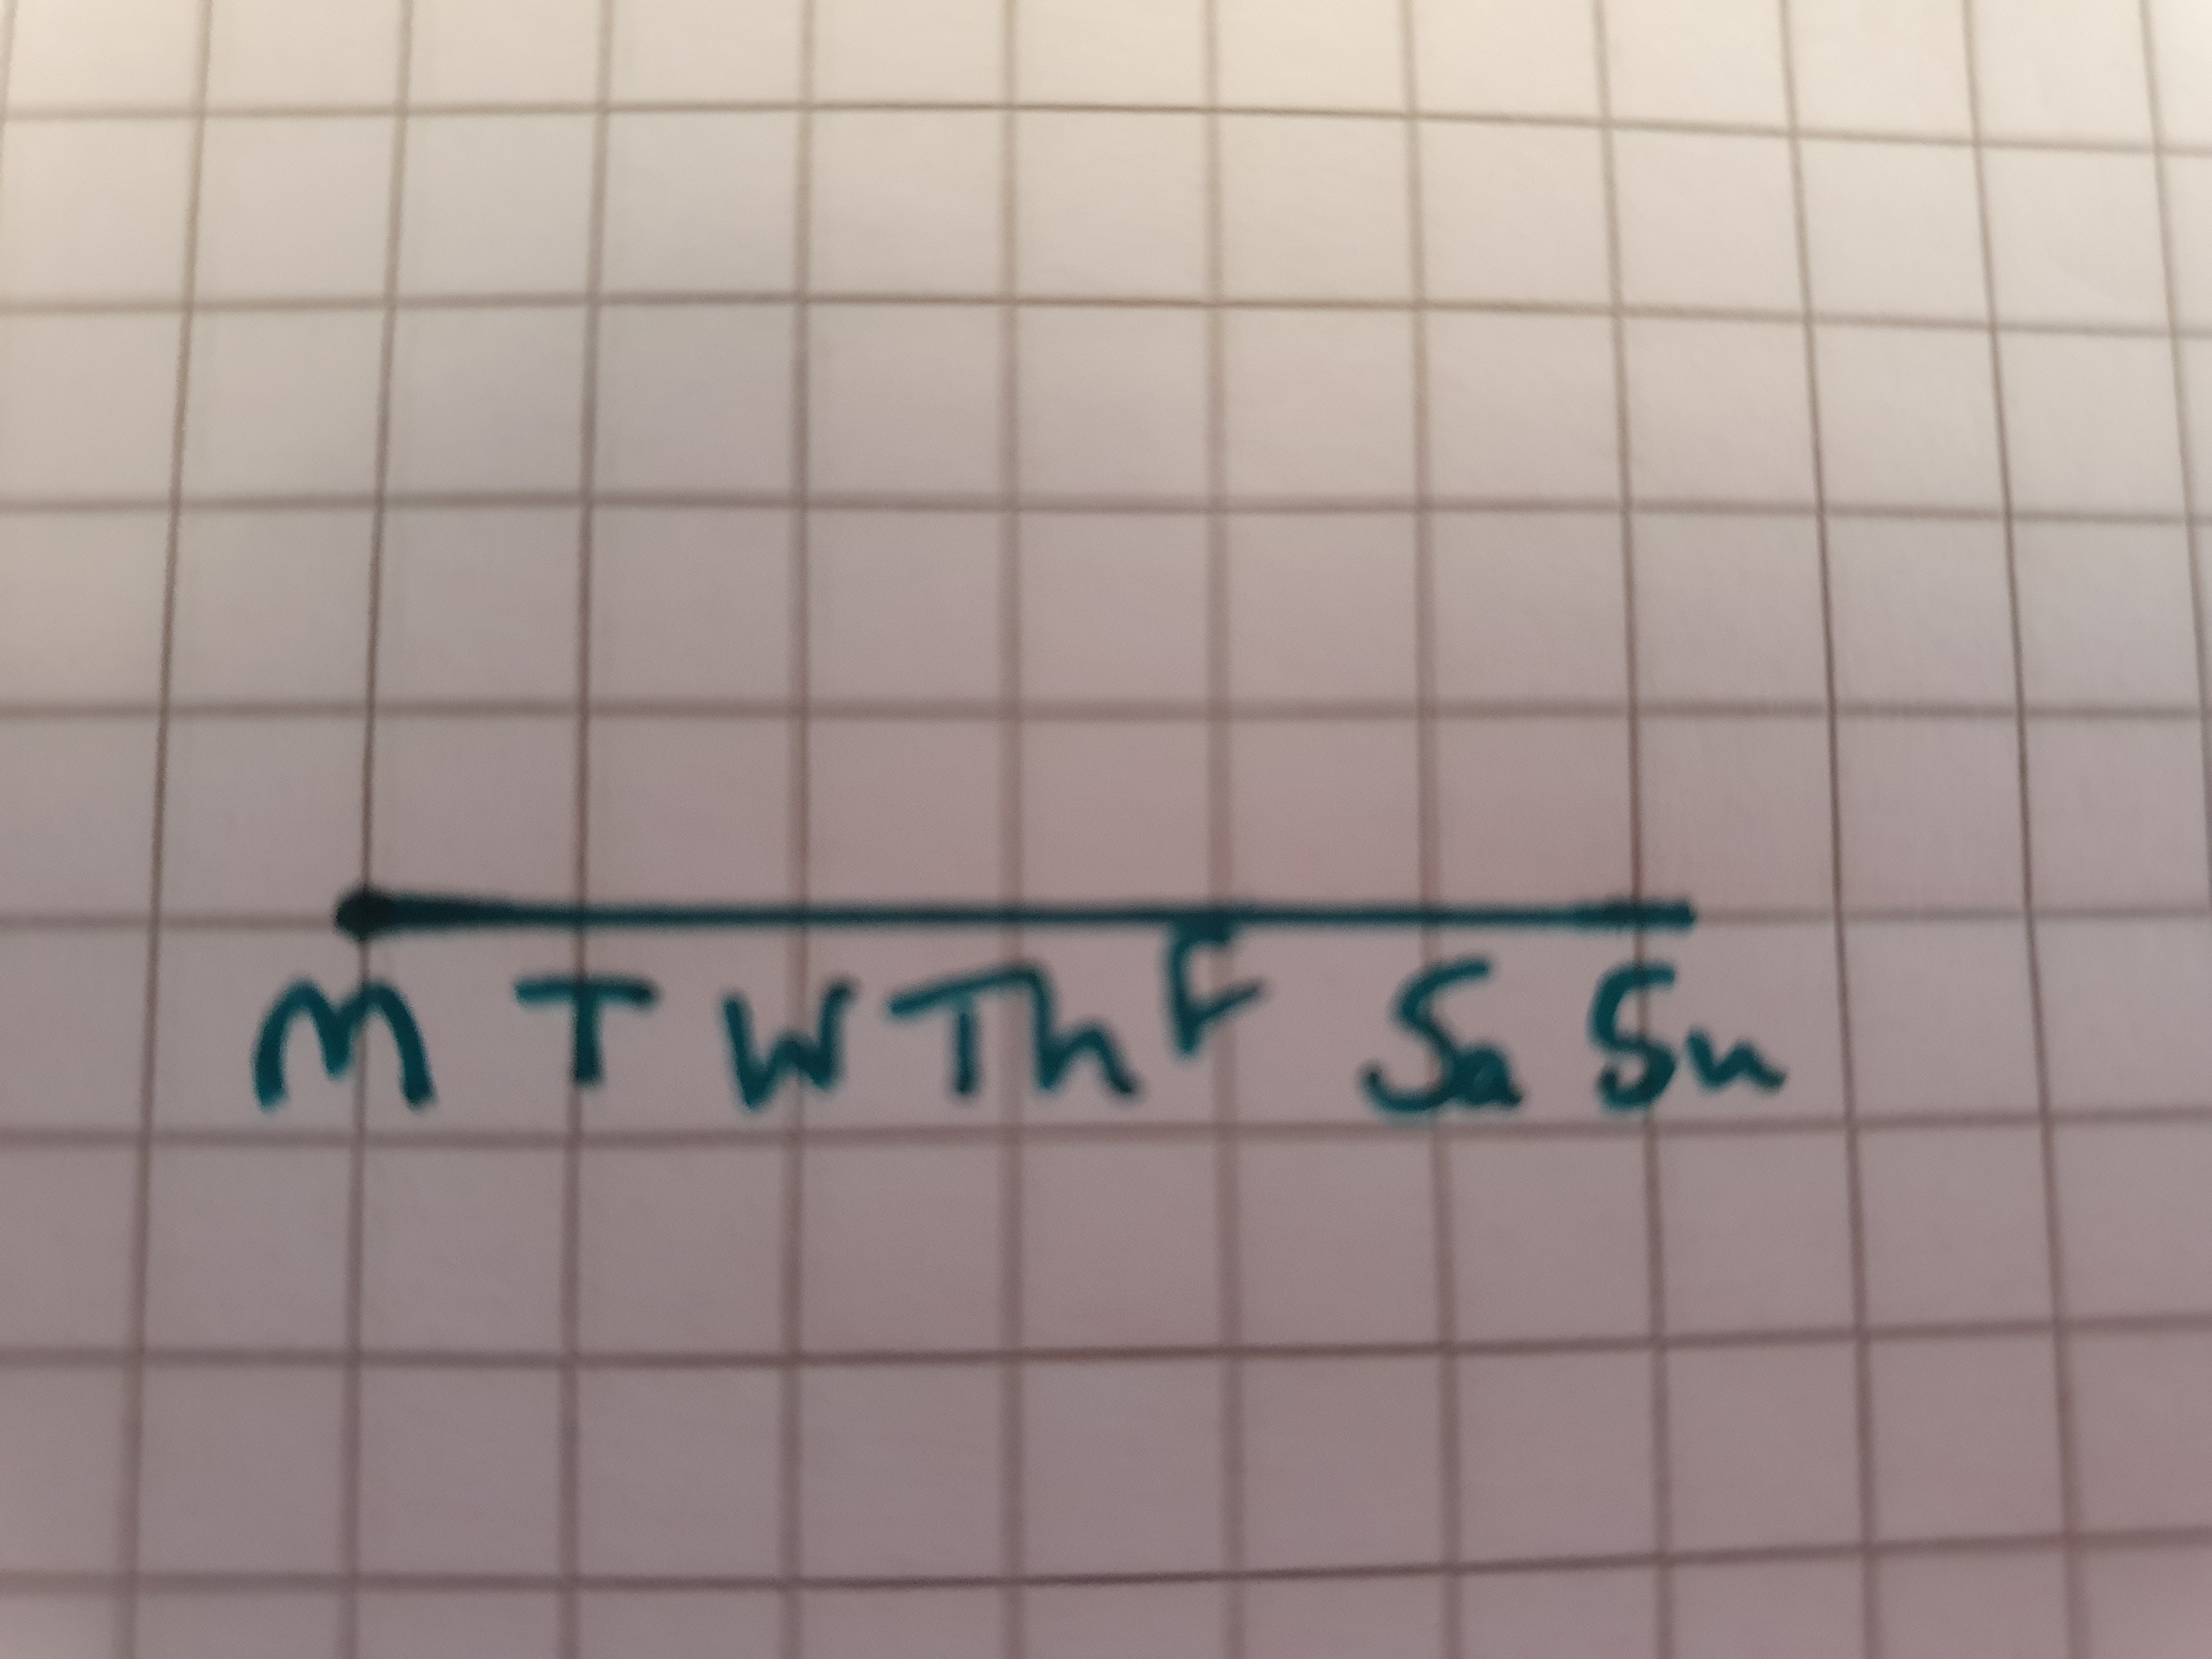

Or you can draw them with two spaces between. Whatever you choose, make sure you have the same number of spaces between each one. I find it useful to count the number of squares I need first to make sure I don’t run out of room.

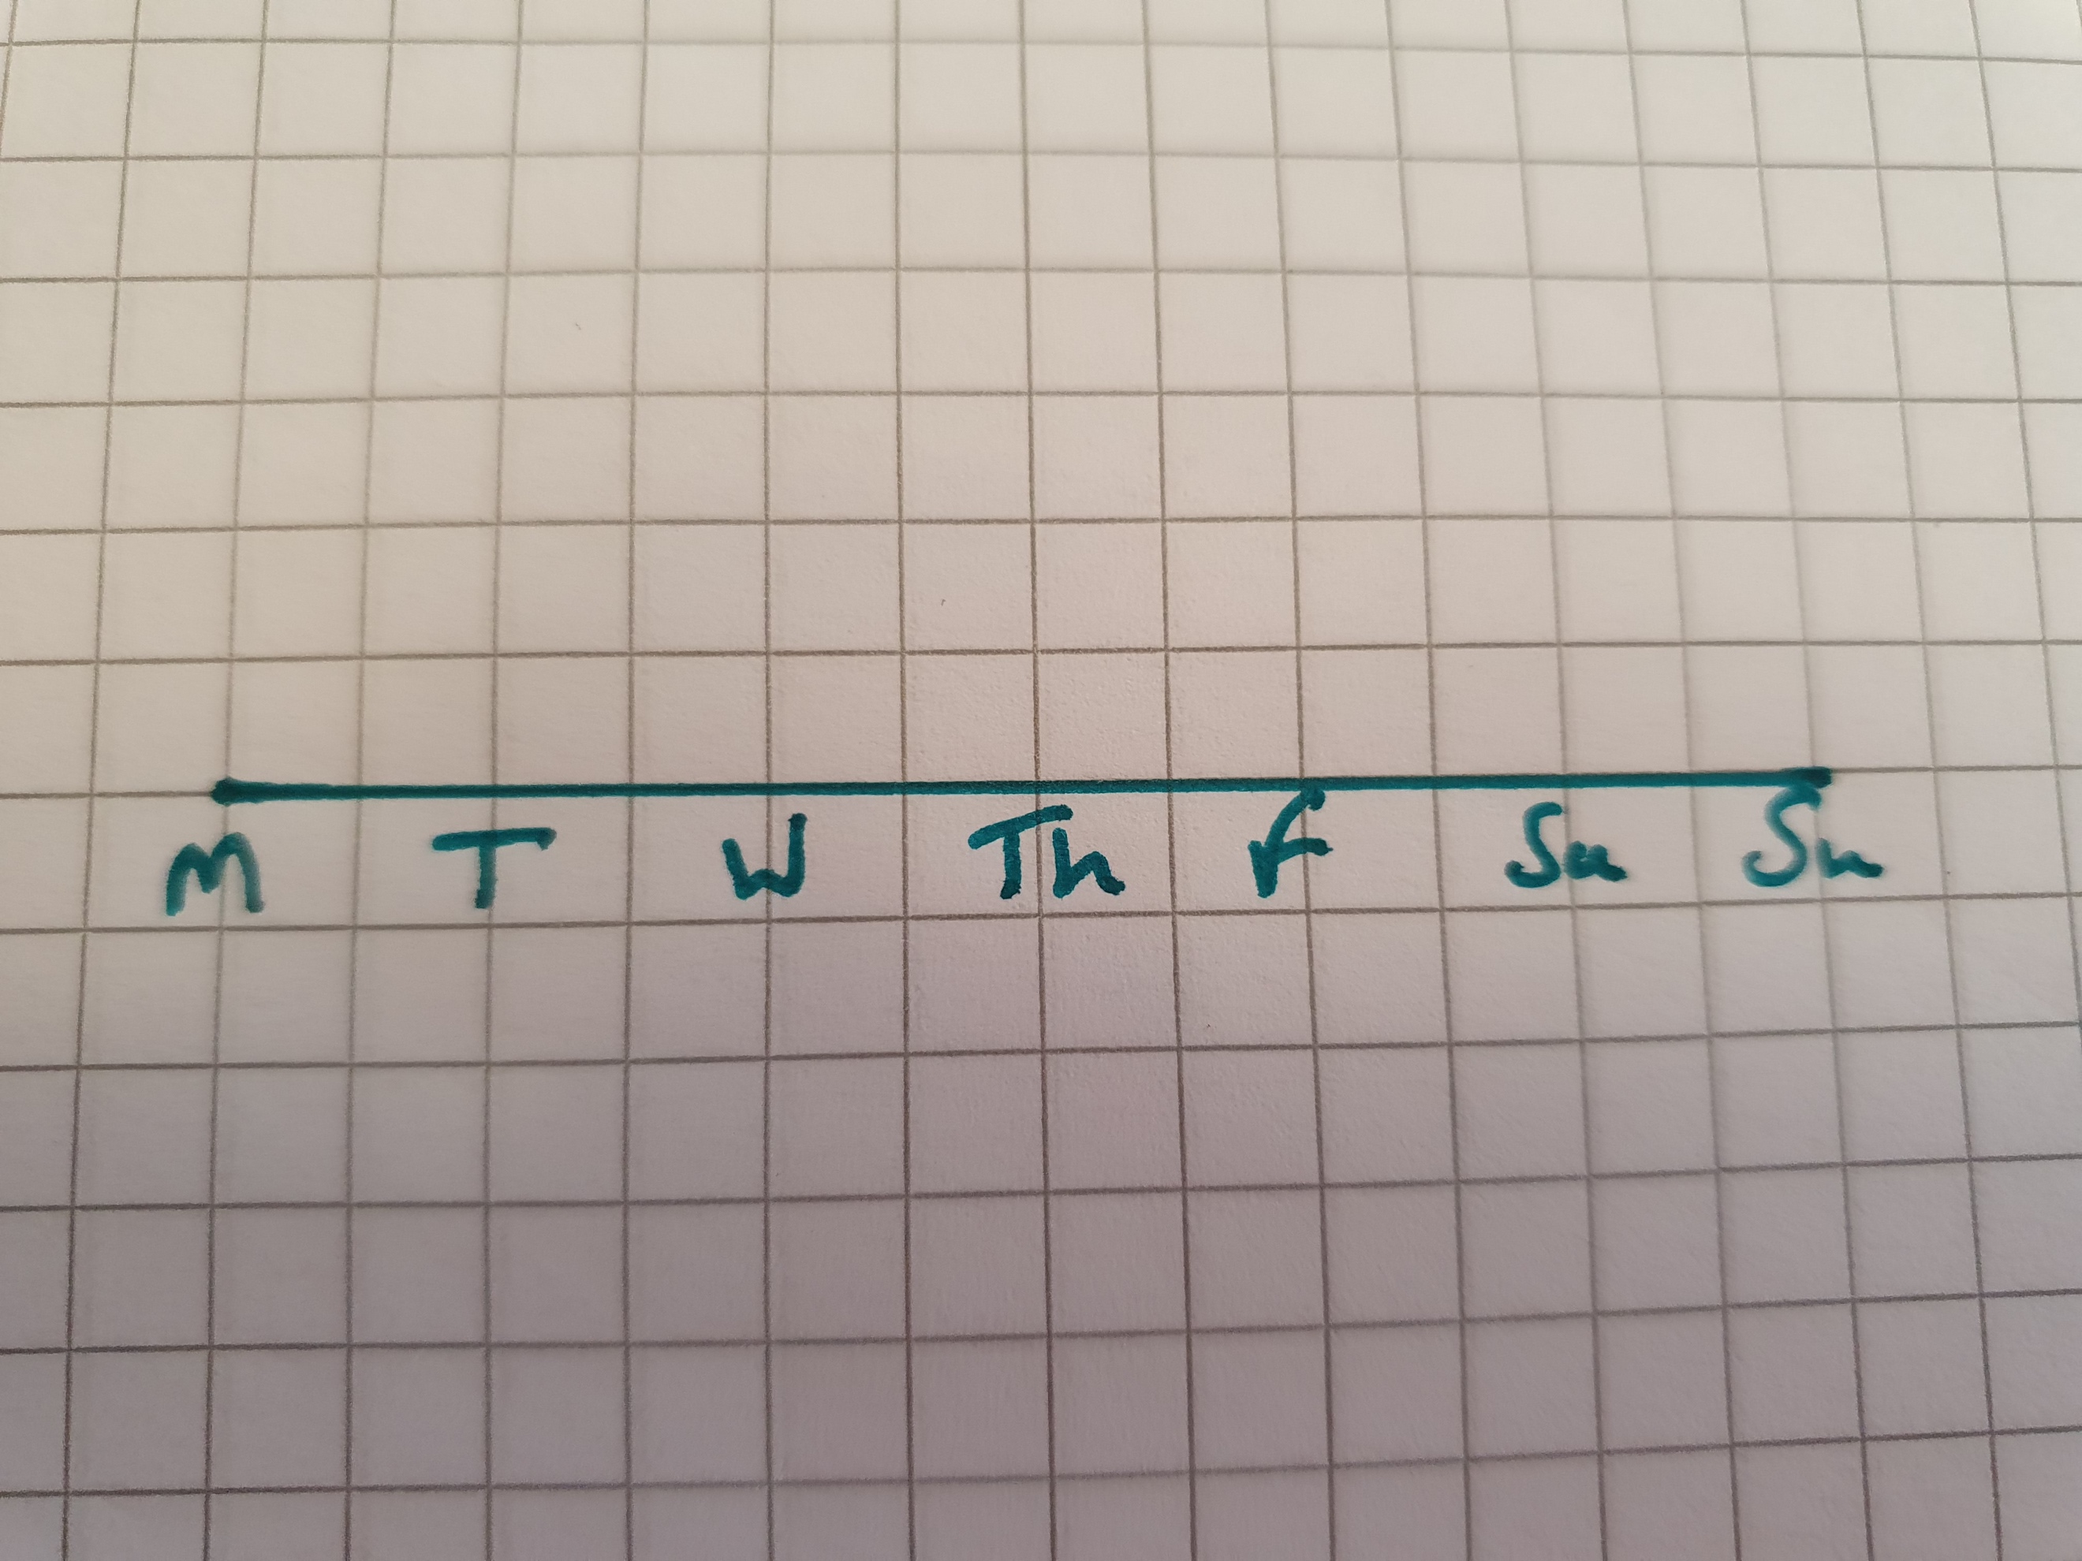

Make sure to use a ruler for the line.

Add a label to your x-axis. Something like ‘Days of the week’ is fine.

Now your y-axis. This needs to go up to 20. Again, you can choose how to spread them out – just make sure they go up in equal steps (I’ve chosen to go up by 2 each time) and I have 2 spaces between each of my numbers. See below.

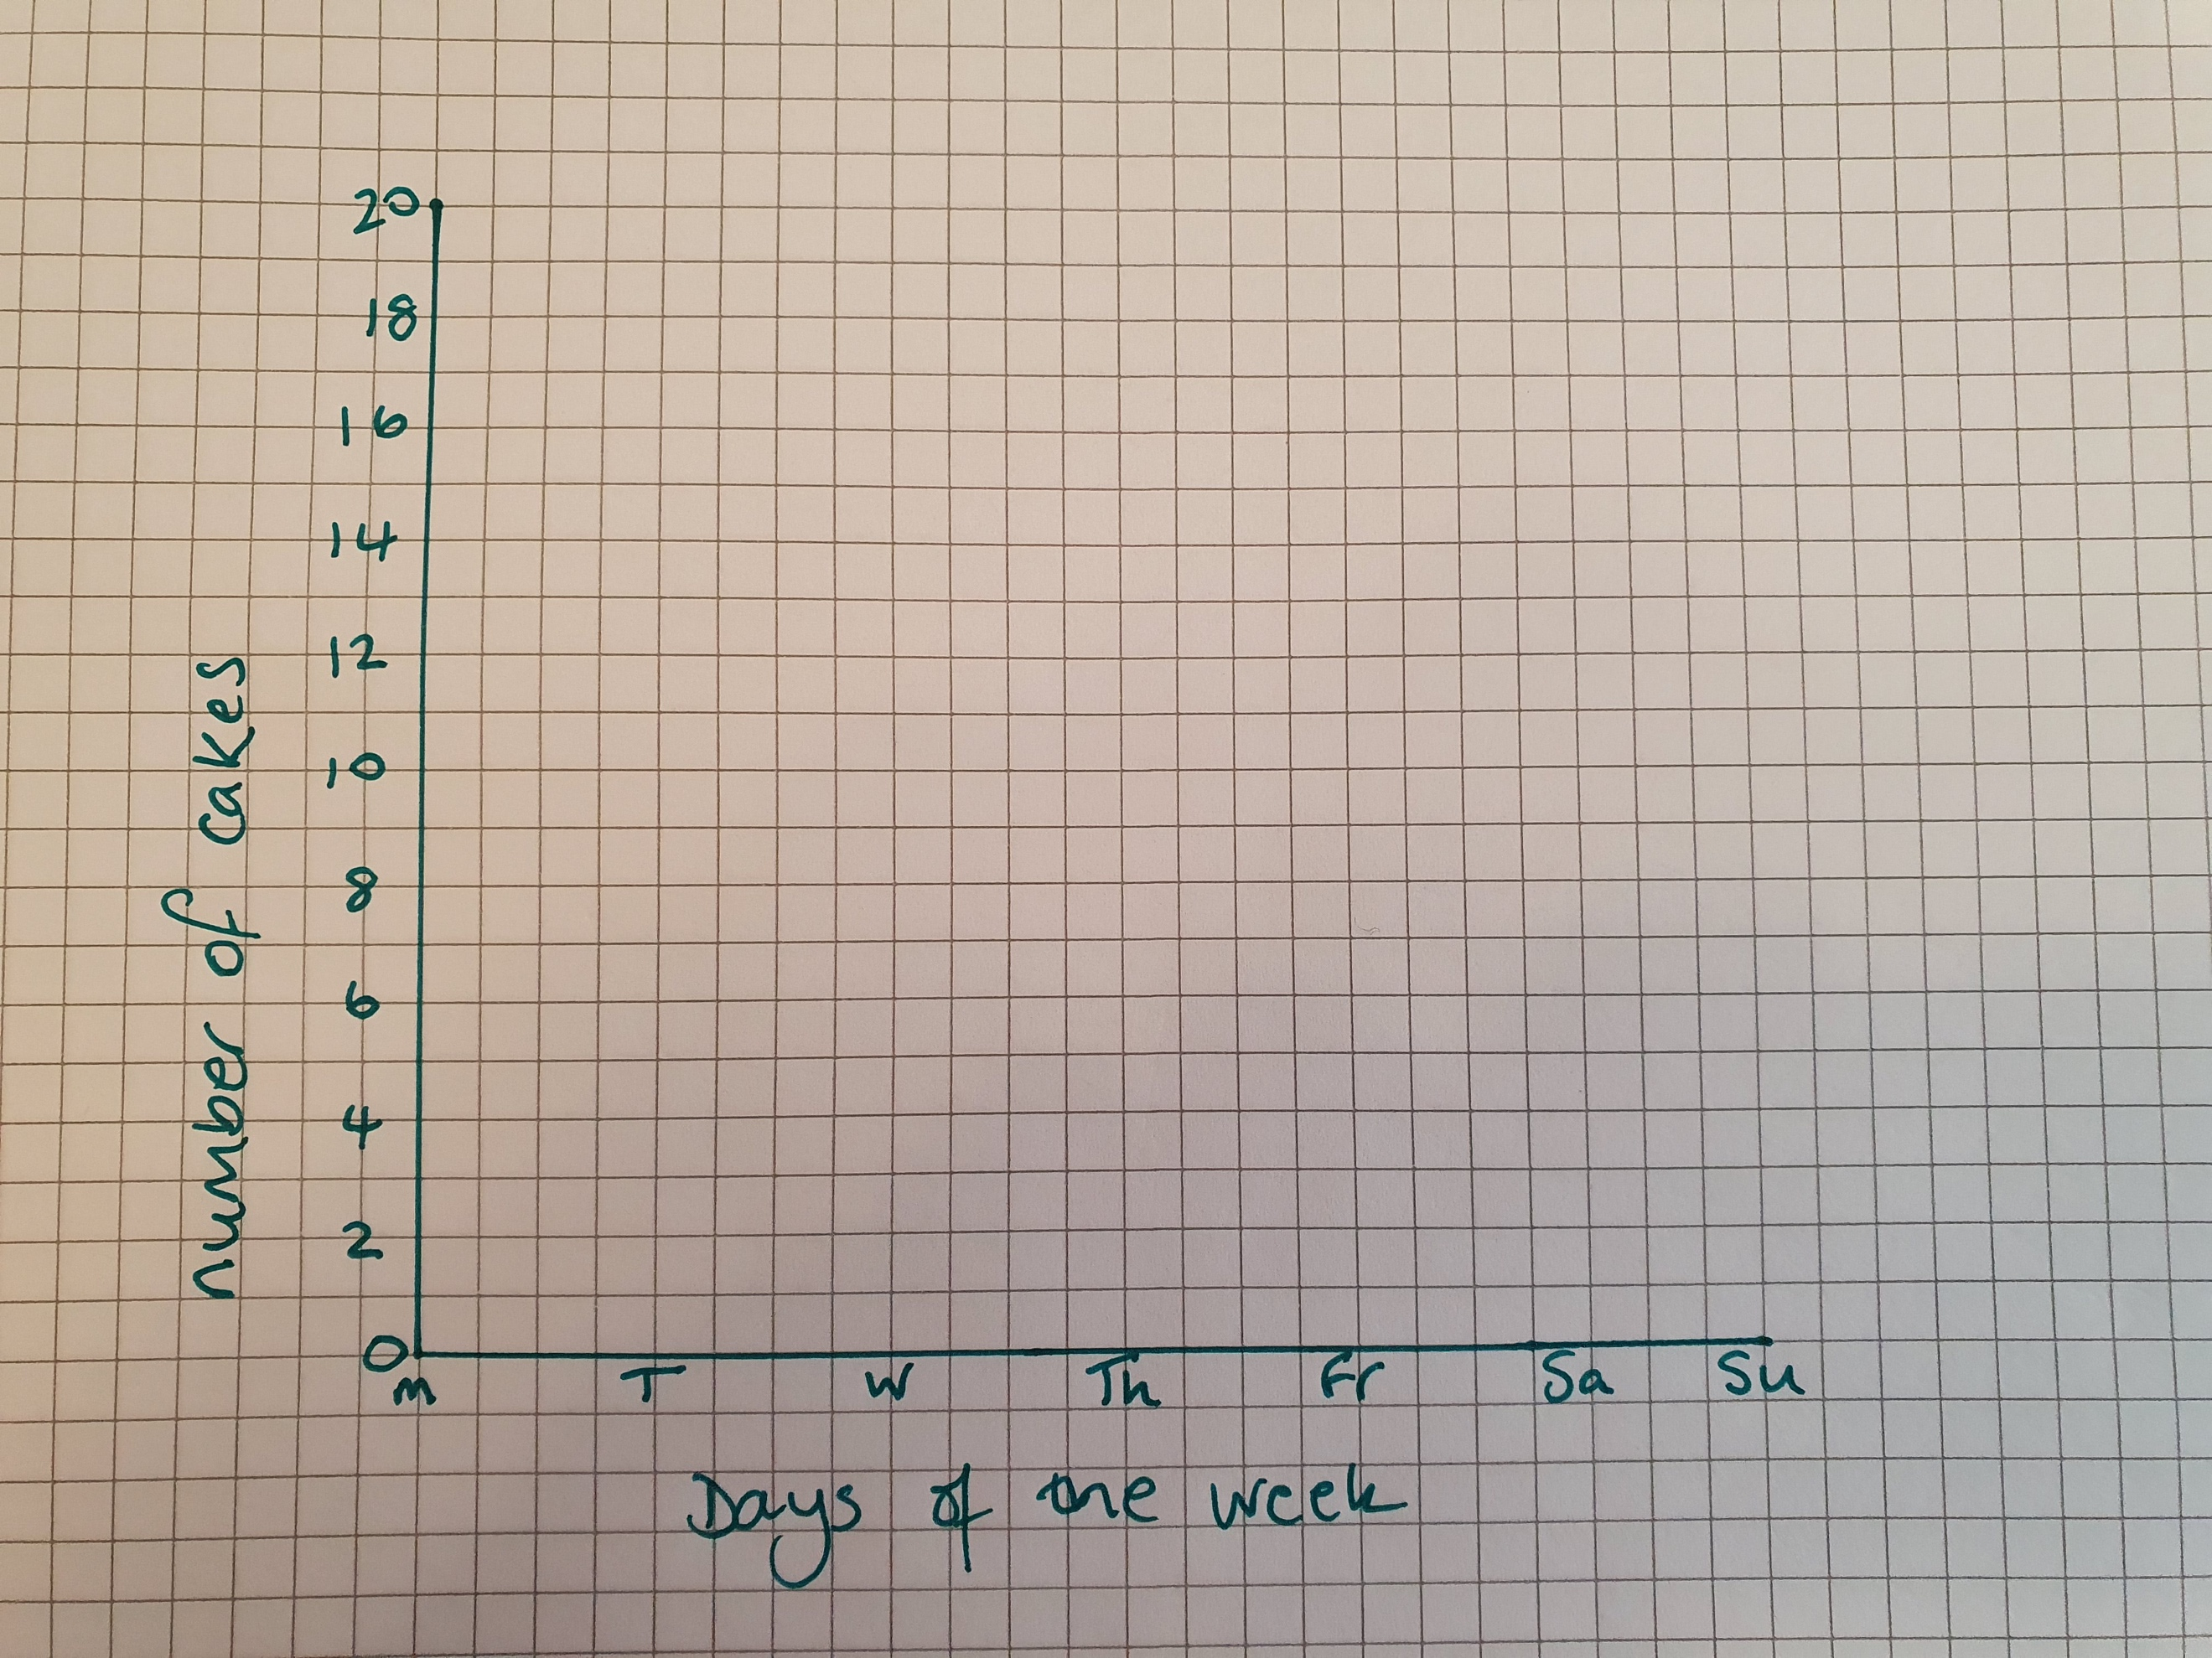

I also decided to spread my days out a bit as my squares are quite small. You can see I have 4 squares between each one.

Next, we need to plot the information.

Day | Mon | Tues | Weds | Thurs | Fri | Sat | Sun
Cakes | 2 | 1 | 20 | 16 | 6 | 4 | 4

I start by lining up with the Monday line (this is the easiest as it is the y-axis line as well). Now I go up to the line level with the number 2. Next I draw a little cross.

I do the same for Tuesday – finding the line for 1.

This is how it looks now:

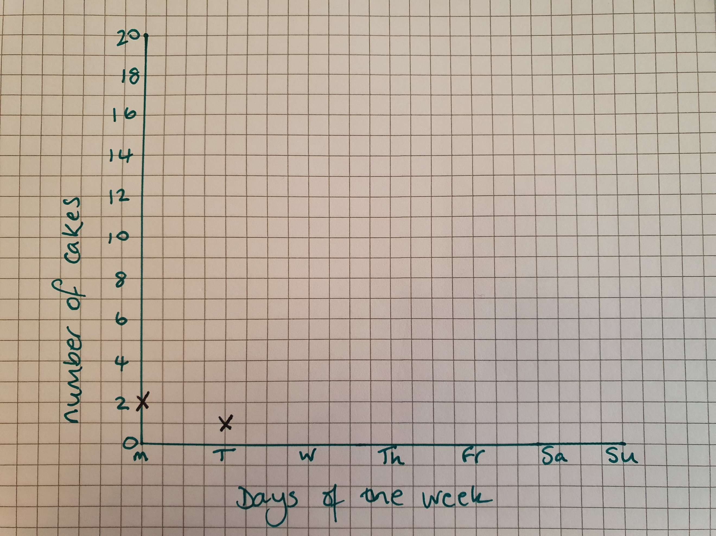

Now you continue with your graph and add in the rest of the crosses.

When you have finished putting the crosses in, draw a line joining them all up. You can use a ruler if it helps. Just do your best to make the line pass through each cross.

Now, use your graph to answer these questions.

- What day do you think Ms Haden went shopping? Why do you think so?
- How many cakes were eaten between Friday and Saturday?
- Which day was Ms Haden very hungry / greedy?
- Were there any days when no cakes were eaten?
- Did I have more or fewer cakes at the end of the week than the beginning?
- Have a look at my finished graph below. Compare it with yours. What is missing from my graph?

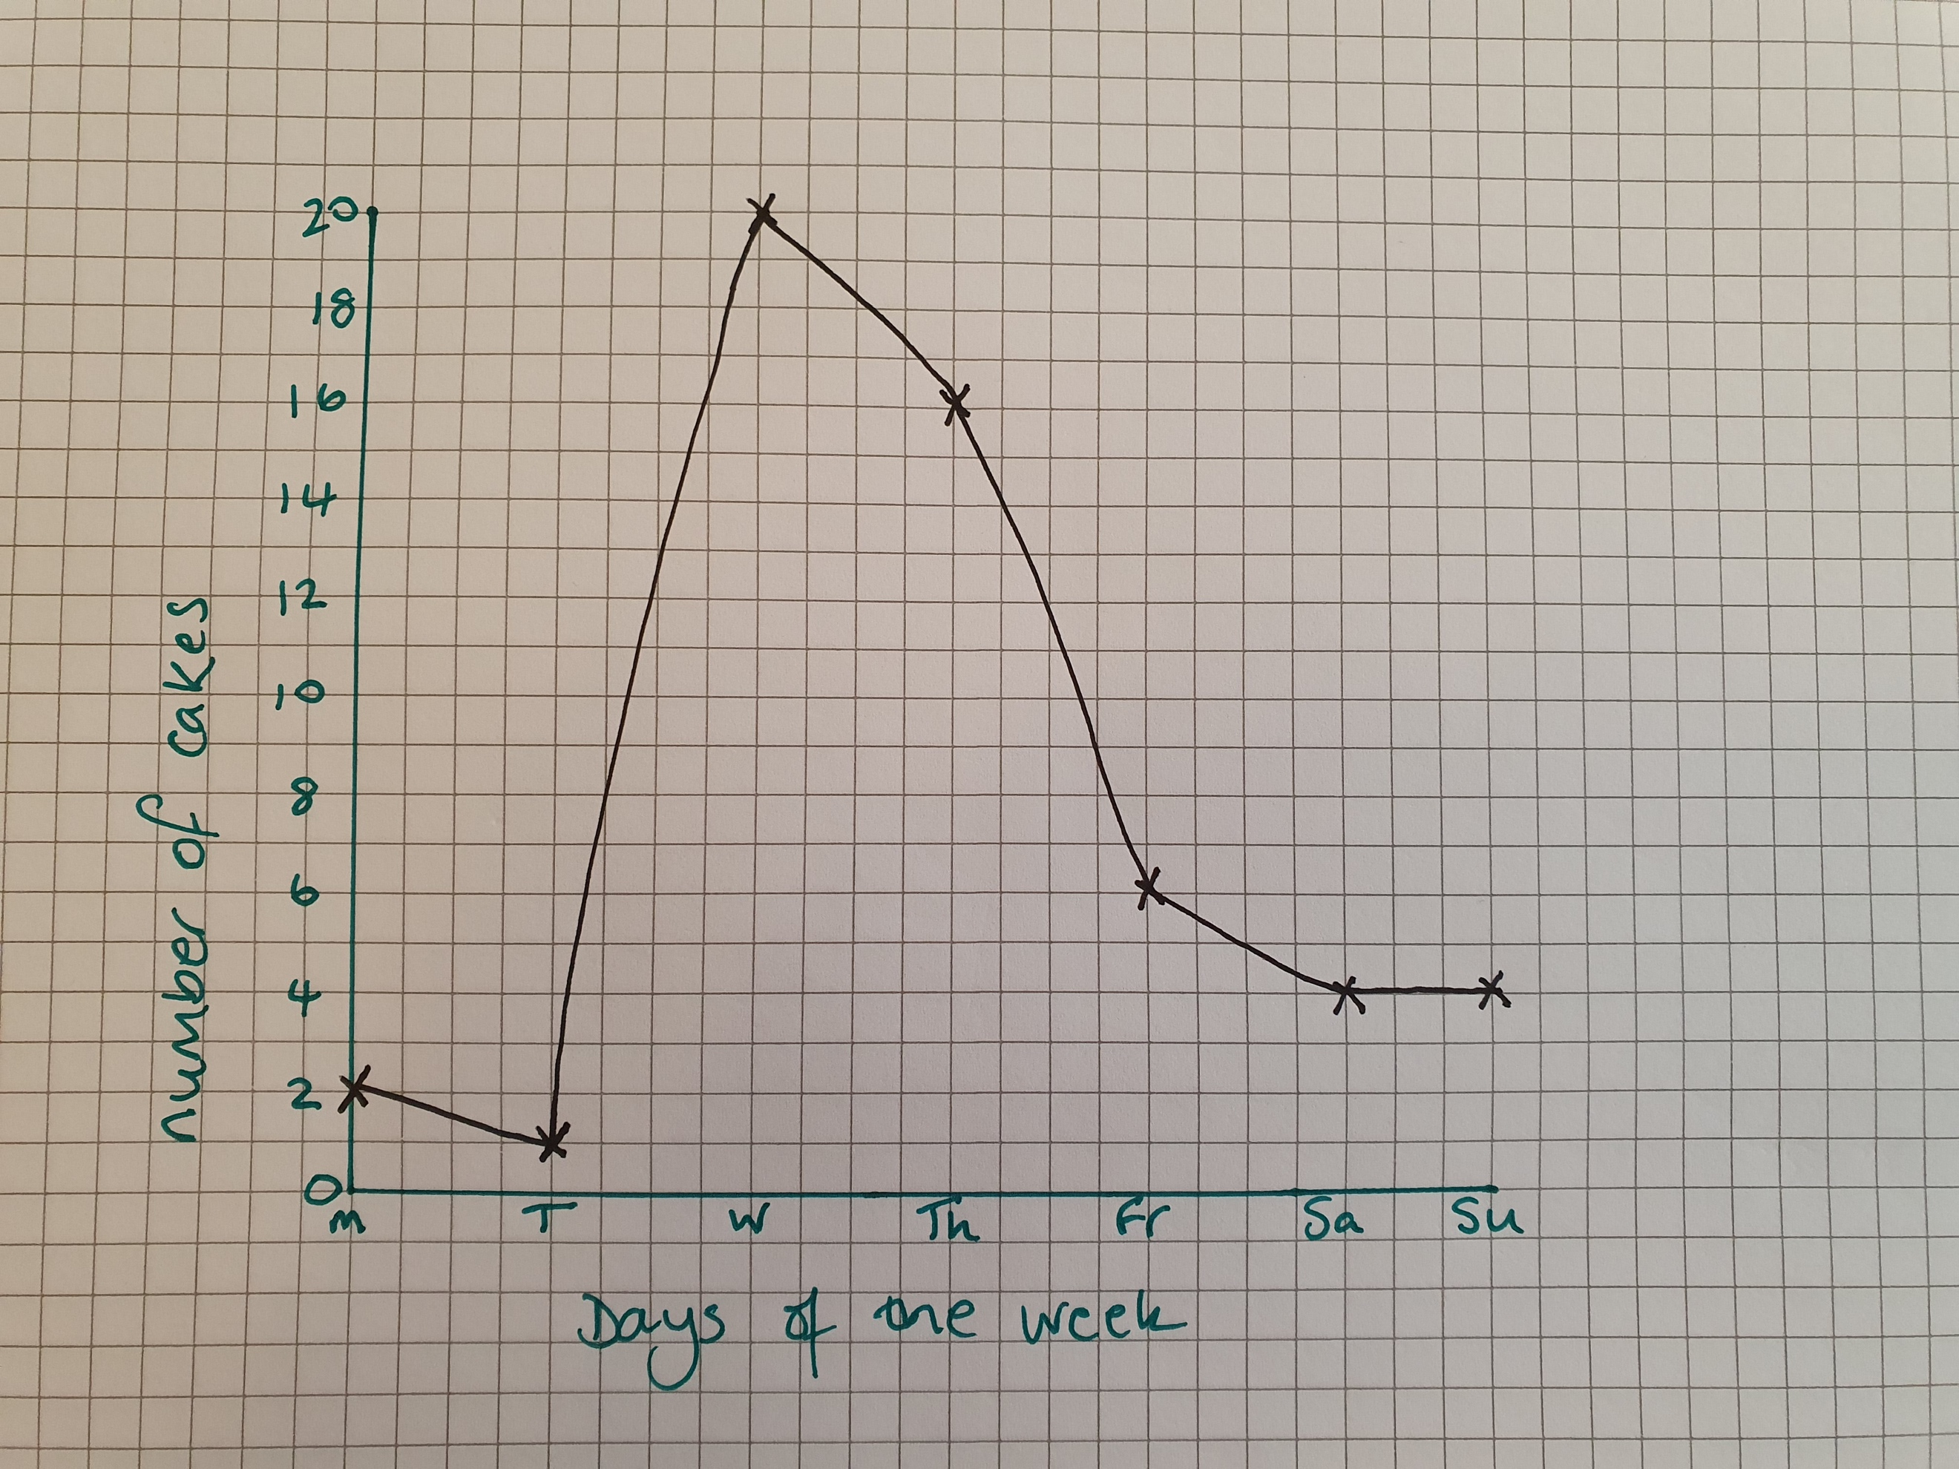

Graphs are tricky. If you would like some feedback on your own graphs, please take a photo and email them to mathsdepartment@woodhouseacademy.staffs.sch.uk, put my name (Ms Haden) on the email and they will get forwarded to me for checking – don’t worry if you need a few tries or there is lots of rubbing out…you will get the hang of these with practice

