Year 7 history home-learning
Medieval society: the Black Death 1348- 1350
Learning objectives:
- To understand what caused the Black Death in 1348.
- To investigate how it spread and how people at the time thought you could cure it.
- To evaluate the consequences of the Black Death.
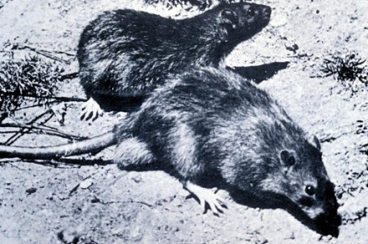
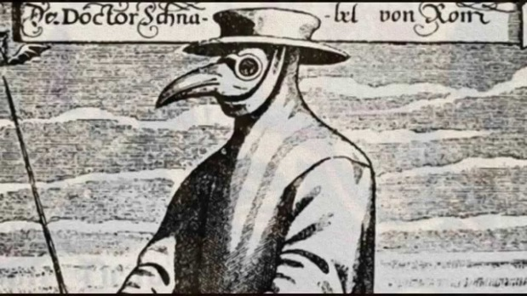
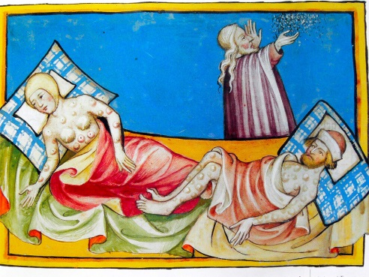
Starter activity:
Have you ever heard of the Black Death? Do the pictures above jog your memory? If so, write a list of what you already know, or think you know about it. Where have you heard this information before?
Main activity:
The Black Death was one of the most infamous events to occur during the medieval period. It was a deadly plague causing an estimated 20 million deaths in Europe.
You are going to carry out some research to complete a project about the Black Death that will take a couple of week’s work of lessons to complete. You perhaps spend two hours on this each week, breaking those down into 30 minute or 1 hour chunks. You could tick off the success criteria as you go.
Your project can be in the form of a PowerPoint presentation if you have access to a PC or it can be a handwritten poster or leaflet. If you decide on the PowerPoint option, text MUST NOT be copied and pasted. Clear bullet points that you understand and can create yourself are much better!
Your project should contain information about:
- The causes of the Black Death
- How it spread throughout Europe and where it is believed to have come from
- The symptoms of the Black Death- what happened to a person who caught it?
- What was the difference between the pneumonic Plague and the Bubonic Plague? Could you have both at the same time?
- What people believed at the time would cure the Black Death, and whether you think any of these would have worked.
- The consequences of the Black Death on England both in the short-term and the long term.
- Any similarities between the Black Death and COVID19.
- Any other interesting facts you have found out.
- Images that support your research. These could be primary or secondary sources, maps or diagrams.
- Your information should not be copied and pasted, and instead written in your own words.
- You should include some information about where you got your information from.
Here are some suggestions of where to find child-friendly information for your project:
https://www.bbc.co.uk/bitesize/guides/z7r7hyc/revision/1
https://ks3historyhelp.weebly.com/the-black-death.html
https://www.dkfindout.com/uk/history/black-death/
A website that includes a recorded reading of the webpage, for pupils who might struggle with reading: https://www.ducksters.com/history/middle_ages_black_death.php
A quiz to check your knowledge here: https://www.educationquizzes.com/ks3/history/the-black-death-01/
Some Black Death games here: http://ks3historygames.co.uk/the-black-death-ks3-history/
If you do not have access to the internet, some information worksheets have also been attached. A combination of the two resources is also fine.

