Climate data for The North of Italy
Month | Temperature (°C) | Rainfall/Snow (mm)
January | -3 | 53
February | -1 | 48
March | 1 | 85
April | 5 | 138
May | 8 | 130
June | 13 | 142
July | 15 | 142
August | 14 | 128
September | 13 | 127
October | 8 | 129
November | 4 | 128
December | -2 | 60

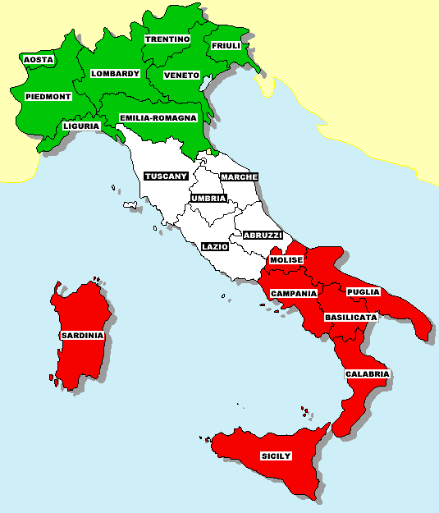

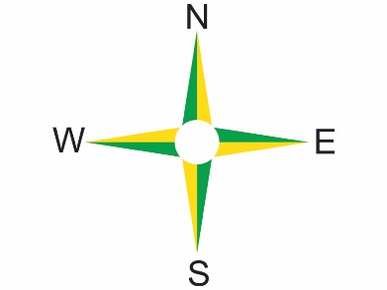

Climate data for Mid Italy
Month | Temperature (°C) | Rainfall (mm)
January | 8 | 70
February | 9 | 60
March | 10 | 58
April | 13 | 50
May | 17 | 43
June | 21 | 37
July | 25 | 15
August | 25 | 20
September | 21 | 60
October | 17 | 100
November | 13 | 130
December | 10 | 90

Climate data for The South of Italy
Month | Temperature (°C) | Rainfall (mm)
January | 11 | 70
February | 12 | 40
March | 13 | 50
April | 15 | 50
May | 18 | 18
June | 23 | 5
July | 35 | 0
August | 36 | 18
September | 24 | 40
October | 20 | 70
November | 18 | 62
December | 15 | 57

