Investigation task:

Is Italy more or less developed than the UK (using the HDI criteria)?
Use the evidence below to answer the following questions:
- In which country do people earn more money?
- In which country do people live longer?
- In which country can more people read and write?
- So, which country would be a better place to live?
Evidence:
GDP: The average amount of money people earn over a year
Life Expectancy: How long, on average, people live for
Literacy Rate: How many people can read and write (as a percent)
Italy: The UK:
GDP | £27,895
Life Expectancy | 82.8
Literacy Rate | 98.85%
GDP | £32,700
Life Expectancy | 80.17
Literacy Rate | 99%
Explanation:
The evidence supports my decision that ________ is the more developed country because the 3 bits of information in the table are used to judge a countries HDI. The higher a country scores, the more developed it is.
GDP means______________________________________________, so a higher number is better because________________________________________________________
Life expectancy means _____________________________________, so a higher number is better because________________________________________________________
Literacy rate means _______________________________________, so a higher number is better because________________________________________________________

Does the UK or Italy make more money from trading with other countries (selling their goods)?
Use the evidence below to answer the following question:
Which country makes the most money from trading? _________________
Evidence:
- An export is something that a country sells to another country in order to make money
- An import is something that a country buys from another country so this costs money
- Therefore, the money made from trading is calculated by subtracting the amount of money a country spends on imports, from the amount it earns from exports.
The UK’s Trade: Italy’s Trade:
Exports | £314 billion
Imports | £491 billion
Money made from trading | -£177 billion
Top exports | Cars, medicines, petrol, gold
Exports | £383 billion
Imports | £351 billion
Money made from trading | £32 billion
Top exports | Medicines, cars, petrol, building materials

Explanation:
The evidence supports my decision that ________ makes the most money from trading because this country makes £___ billion from trading which is more than __________.
To work out how much money is made from trading you have to subtract the amount of money a country spends on imports, from the amount it earns from exports. An import is__________________________________________________. An export is ____________________________________________________. The evidence tells us that Italy’s top exports include_______________________________________, and The UKs top exports include _________________________________________.
In fact, the evidence shows us that the UK doesn’t trade very successfully as they lose money. This is because the amount they _____________ is greater than the amount they ____________.

Is the North or South of Italy more developed?
Use the evidence below to answer the following questions:
- Which part of Italy (the north or south) suffers from the most unemployment? (The darker the colour, the higher the percentage of people who are unemployed) ______________________
- Which part of Italy (the north or south) has more wealth? (The darker the colour, the more money is earned there)______________________
- So, which part of Italy is more developed (a better place to live)? ________
Evidence:
Unemployment= People without jobs
Wealth= The amount of money made
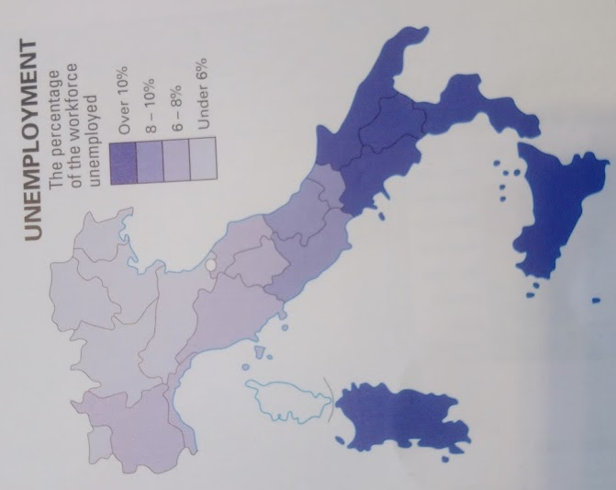

Explanation:
The evidence supports my decision that the __________ of Italy is more developed because its shows that this part of the country earns a lot more money. It also shows that in the _________ a lot more people are unemployed, which means ___________________.
The unemployment maps shows that in the south of Italy is coloured dark blue. The dark blue colour means _________________________________, whereas in the north of Italy is is the lightest blue which means _____________________________________. The wealth map shows that the north of Italy has lots of areas which are a dark green colour. The dark green colour means _______________________________________, whereas in the south of Italy it is the lightest green colour which means_______________________________.

