

Food Activity sheets

The following activity sheets are for you to work through over the next few weeks. You can create your own documents with the work on – using the computer or hand written/drawn.



Woodhouse Academy

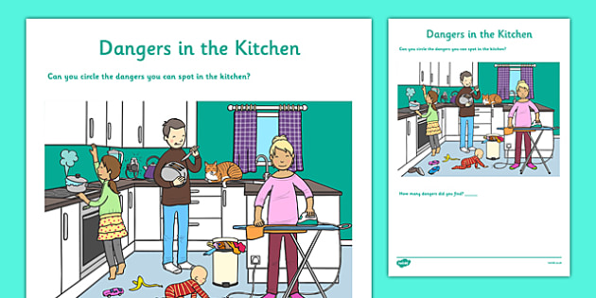

Can you spot the dangers in the kitchen?

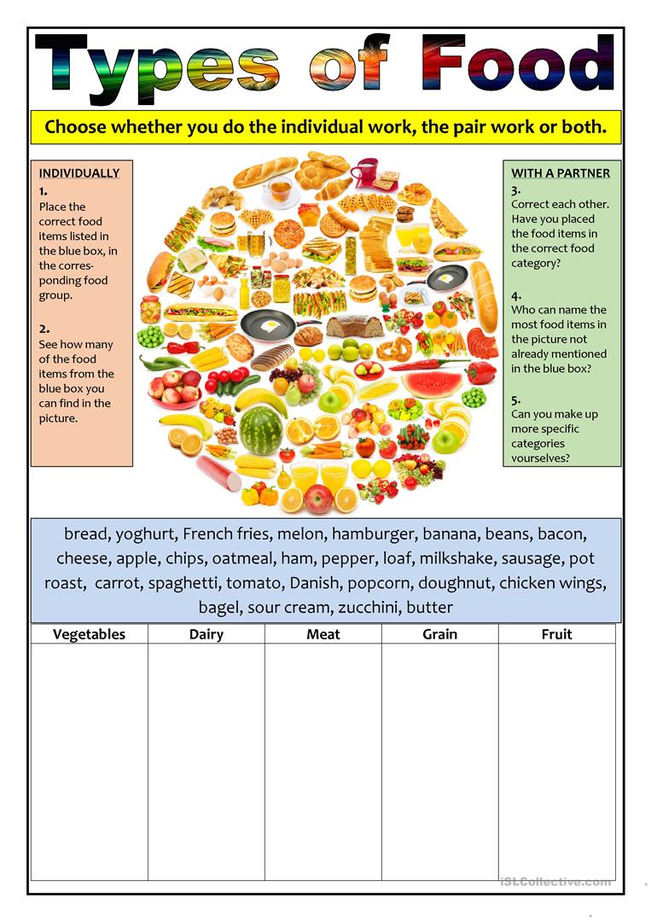

**Complete the columns below. You can follow the task with another person.**

Bread, yoghurt, French fries, melon, burger, banana, beans, bacon, cheese, apple, porridge, ham, pepper, milkshake, sausage, carrot, spaghetti, tomato, popcorn, doughnut, chicken, bagel, sour cream, courgette, butter, sausage, pineapple, peas, orange, hash browns, pasta, lettuce, ice-cream, rice, egg, noodles

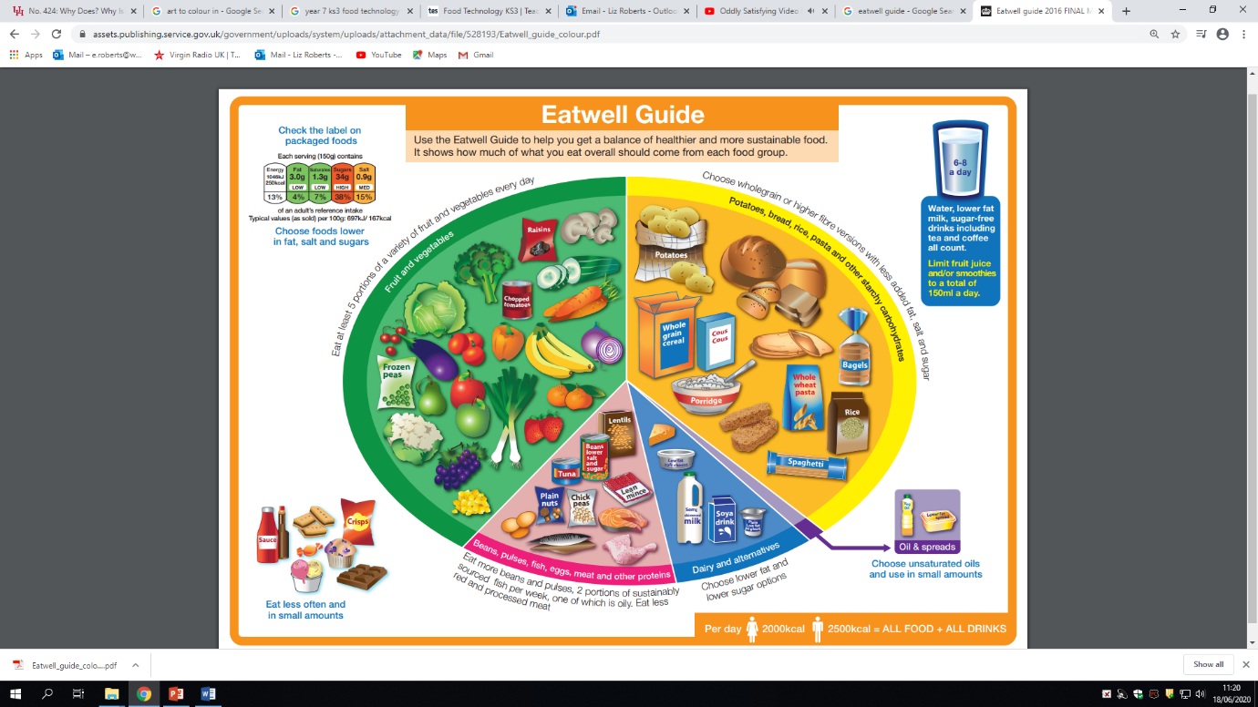

Task 6: Research into the different sections of the Eatwell guide and write up why they are good for us and what the body needs it for.

Task 5: create your own Eatwell plate from what you ate yesterday. Do you feel you have eaten a healthy balanced diet?

Task 3: Looking at the top left hand corner, why do you think food packaging has changed to include traffic light labels?

Task 2: Why do you think all the sections are different on the guide?

Task 3: Create a food diary for the last 5 days and include all the foods you have eaten from the Eatwell guide.

Create

Task 1: write down a sentence to explain why this advert had to be created by the Government.

