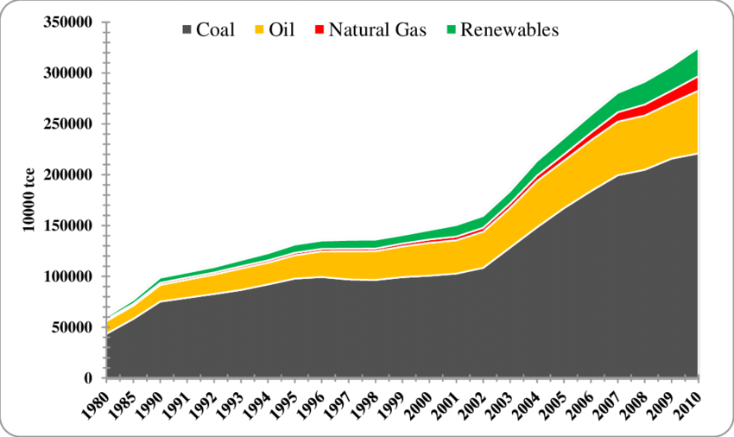
What does the evidence show us?

Answer the following questions:
- What trend does the graph show? (what is happening to all of the energy sources China is using?
The trend since 1980 has been that China is using more and more energy sources. In fact, the amount they are using has increased dramatically.
- Which 2 types of energy source does China use the most?
Coal and Oil
- Why is this bad for the environment?
Coal and oil are fossil fuels which will create air pollution when they are burned to create energy.
- What type of energy does the green line show that China has started to use more of?
Renewable energy
- Why is this a good thing?
Renewable energy does not use fossil fuels and so creates energy in a ‘clean’ way without creating pollution.
What does the evidence show us?
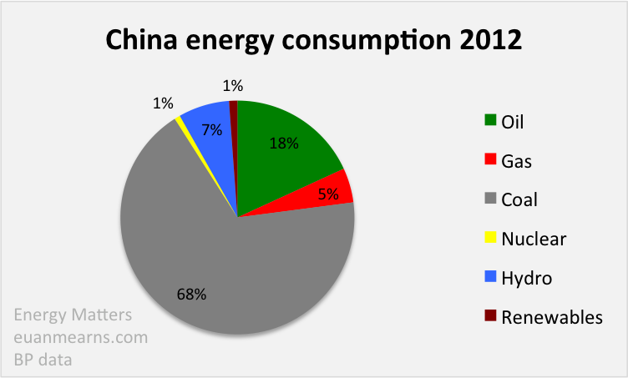

- What percent of the energy China uses is created by burning fossil fuels (oil, gas, coal)
91%
- What percentage of the energy China uses is created by using renewable energy (such as hydro-electricity, solar power, wind turbines etc)?

8%
- Which type of renewable energy does China mostly use?
Hydro-electricity
- Why is it good that China have now started to use some renewable energy?
Even though the percent of renewable energy being used is very low, it is good that China have started to think about using more clean energy sources and hopefully that will mean they start to use more and more in the future. This would mean they could stop using as much non-renewable energy and so create less pollution.

