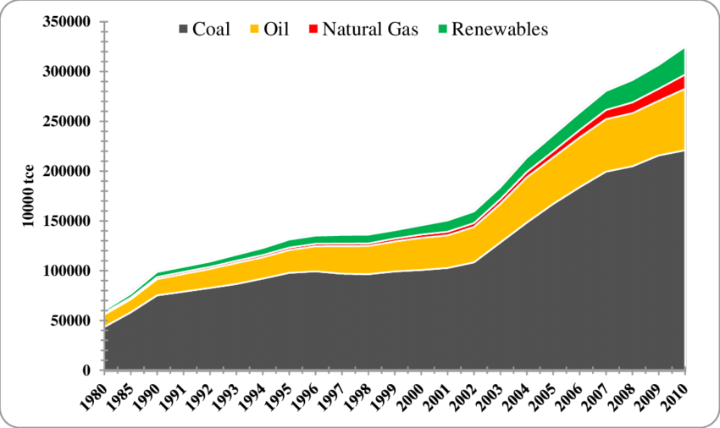
What does the evidence show us?

Answer the following questions:
- What trend does the graph show? (what is happening to all of the energy sources China is using?

- Which 2 types of energy source does China use the most?

- Why is this bad for the environment?

- What type of energy does the green line show that China has started to use more of?

- Why is this a good thing?

What does the evidence show us?
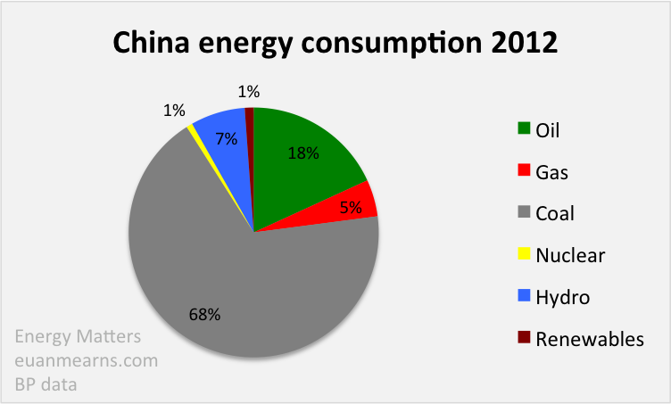

- What percent of the energy China uses is created by burning fossil fuels (oil, gas, coal)

- What percentage of the energy China uses is created by using renewable energy (such as hydro-electricity, solar power, wind turbines etc)?

- Which type of renewable energy does China mostly use?

- Why is it good that China have now started to use some renewable energy?

